[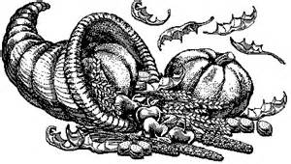](http://www.bing.com/images/search?q=black+and+white+thanks+giving+clip+art&view=detailv2&&id=4435FCDCDA33B21A91C037F799E283BBE1FCFD6C&selectedIndex=102&ccid=Dj4gLqWR&simid=608015027484164338&thid=OIP.M0e3e202ea591d3b9566fd3661c744bbbH0)

Up coming dates:

November 11th: No School Veteran’s Day

November 17th: Literacy night 5:30- 6:45

November 26th & 27th : No School Thanksgiving

We will be holding Student Council elections on November 2nd, please contact me if you have any questions about this.

Are you ready for Thanksgiving? Student Council will begin selling turkey raffle tickets for $1.00 on Monday, November 9th. The winner will receive a 15 pound turkey and a sack of potatoes from Basha’s on Monday November 23rd.

Thank you for coming to the Fall Festival! This supports our school provide opportunities for our students through PTA, and increasing school spirit!

Ms. Richardson’s

4th Grade November

Newsletter