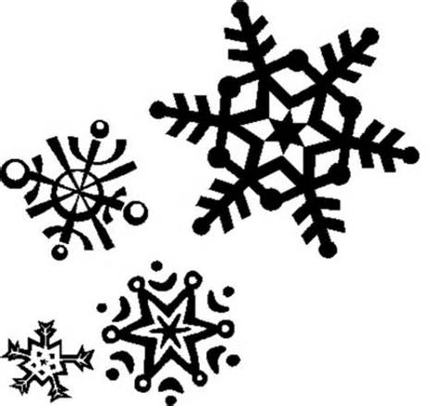 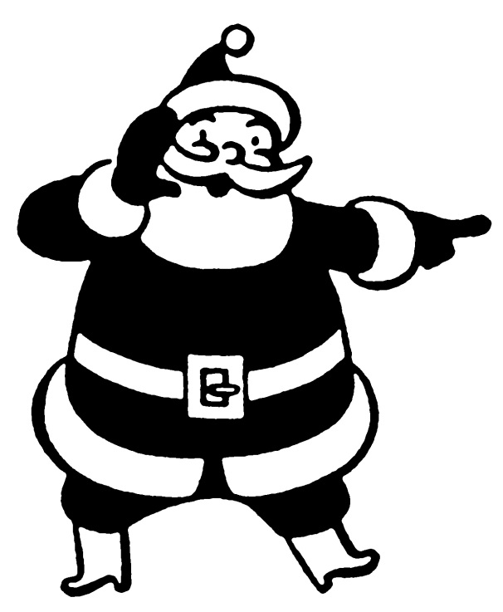 

Up Coming Events:

December 7-11 – Scholastic Book Fair in the Library

December 7–17 – Quarterly Assessments Grades 3-5

December 18 – Grading Day (No School)

December 21-January 1 – Winter Break (No School)

January 18 – Martin Luther

King, Jr. Day (No School)

Ms. Richardson’s

4th Grade December

Newsletter