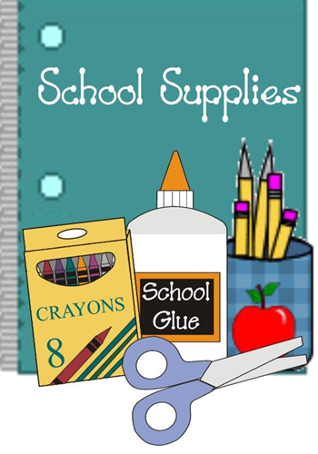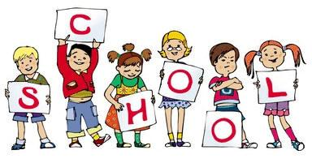

September 2016

Ms. Richardson’s

4th Grade Class

September Newsletter

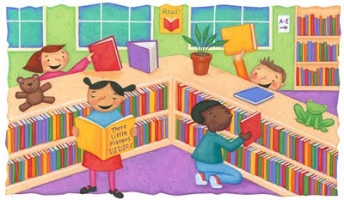

Water Bottles

Please send your son/daughter to school with a water bottle so they can stay comfortable and hydrated during the day!

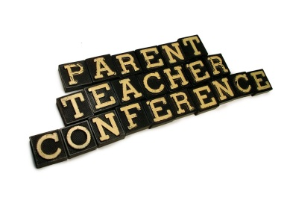

Library Day

Please note: Thursday is our library day! Students that do not bring in their books will not be able to get more. Please remind your child of this on Thursday night. Children are often disappointed when they are not allowed to get new books.

**Grandparents Day Dinner Celebration!**

Sept 8th, 2015 5:15 p.m. - 6:30 p.m.

Blenman Cafeteria

Adults $5.00 Children 12 and under $2.00

​​ @ Door additional $1.00 a ticket

​​​​

www.richardson.webstarts.com

If you have not checked out the class website PLEASE do so. I have placed the picture ordering information, Scholastic, spelling lists, class rules and events that you might like to know about on there. You can get there from the Blenman website, or you can go to: www.richardson.webstarts.com

I will be contacting you about parent teacher conferences. Please sign up for a time with me. If we cannot meet face to face we can phone conference. I will post available slots on my website.

School Supplies

To the parents that have brought in school supplies and things for the class; “Thank you”! The kids and I appreciate all that you do to make sure everyone is taken care of equitably. I have some excellent parents and students this year and I am so grateful for you all. We still need some black three prong folders if you would like to donate. We could also use some snacks and fun things for the classroom store. 4th graders love to be rewarded with little things they love so if you think of some, please send them in!