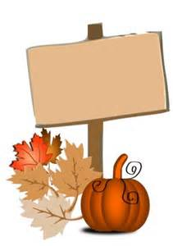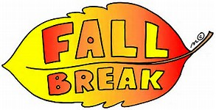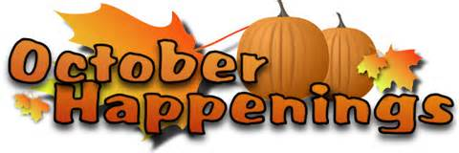

Ms. Richardson’s 4thGrade Class Newsletter October 2015

**“I'm so glad I live in a world where there are Octobers.”**

**― L.M. Montgomery, Anne of Green Gables**

**Thank you to all of the parents and guardians that have volunteered, sent in paper, sanitizer, and other classroom supplies for our children to use! We appreciate YOU so much! I hope to see everyone at the Fall Carnival!**

**October 23rd, 2015 5:30 -7:30**

**Tickets are on sale @ the office and are cheaper if you buy them in advance than at the door.**

**October 9th – 18th 2015**

[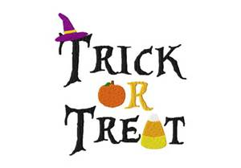](http://www.bing.com/images/search?q=trick+or+treat&view=detailv2&&id=A20721EB78455538C831F4661B5C9EE1A04173B3&selectedIndex=1&ccid=TMmrB79f&simid=608044319055941130&thid=OIP.M4cc9ab07bf5f17baecbb5bf99c39a366H0)

**Saturday Oct 31st. Please remind our little ones how to stay safe and have loads of fun!**