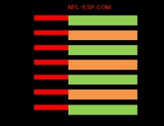
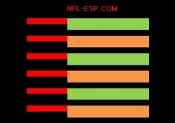
NFL-ESP [EXTENDED STRATEGIC PRINCIPLES]
PROGRAM

PRINCIPLES: | STRATEGIC |  |  | MOTIVATIONAL |  | X’s and O’s |  |  |  | SPIRITUAL
PRE-GAME
MANAGEMENT

 | STRATEGIC PRINCIPLE SYSTEM: |  |  |  |  |  |  | POWER-RATING ___ - ___ =  POWER-SPREAD __  PROBABILITY PERCENTAGE __ %
IN-GAME
MANAGEMENT DECISIONS

 | 7 BASIC STRATEGY COMPONENTS
Score  __ - __ |  | N/A  ___ | V N/A  _ |  | N/A  __ |  | N/A  _ |  | N/A  __ |  | POWER-SPREAD  __
 | 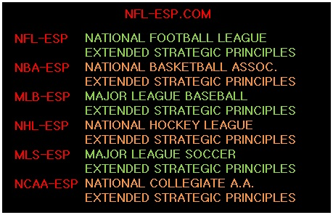 |  |  |  |  |  |  |  |  |  | [PSI] POWER-SPREAD INDEX  __
PROBABILITY PERCENTAGE %
__

NFL-ESP results in a 10-15% increase  in POINT PRODUCTION and team wins. |  |  |  |  |  |  | FINAL SCORE |  |  |  | __ - __
[GMC] GAME MANAGEMENT CONSULTANT/COORDINATOR

