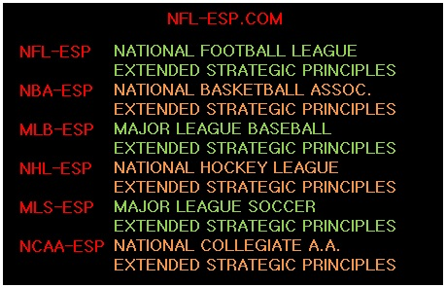

“NBA Moneyball”
[Working Title]
Where would the NBA be without the compliment of shows that add entertainment and insight to the games?
There are studio shows, highlight programs, even fantasy programming. TNT Sports brings fans “Inside the NBA” and CNBC even has a business-minded sports program.
“NBA Moneyball” predicts, reviews, and analyzes the games from the unique perspective of a strategist who has successfully mastered and uses a revolutionary concept called NBA-ESP [Extended Strategic Principles]; and using statistics based on a POWER-RATING and a POWER-SPREAD.
Based in part on the Academy Award® nominated film of the same name; NBA teams seeking a competitive edge, have begun to use such data and form front-office departments seeking such perceptive, fascinating and insightful information.
In addition, while this may, may parallel other widely-distributed numerical information; NBA-ESP’s prized and valuable data and analytical insights can be used by millions-and-millions of other fans who may find this info financially rewarding; not unlike a fantasy basketball program may lend value to fans decision-making or investments in a fantasy basketball league; that in itself, a billion-dollar industry.
In the end, “NBA-Moneyball” carries the newfound tradition, which ESPN has further implemented, of featuring former players or personnel who offer professional and personal perspectives which gives NBA fans unheralded access to the evolution, innovation, and revolution one of the greatest games ever played.

©2016 www.NFL-ESP.com

