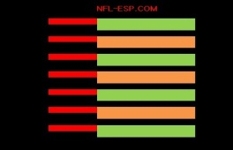
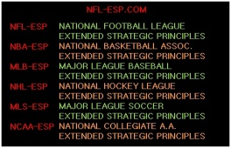
Description of NFL-ESP [Extended Strategic Principles]
“Extended Strategic Principles” is an analytical and STRATEGIC program and system for use in the NFL, NBA, MLB, NHL, MLS, CFL [Canadian Football League], PGA and in NCAA football and basketball. It serves a team in making the most PROBABLE and PRODUCTIVE game management and STRATEGY DECISIONS; thus increasing PRODUCTION, scoring, and wins.

The program incorporates STRATEGIC, MOTIVATIONAL, SPIRITUAL knowledge and X’s and O’s play design proven to increase a team’s win production by at least 10-15% per season!

The key to the STRATEGIC statistical system are exclusive, complex, and highly-accurate team POWER-RATINGS and the numerical difference between teams called the “POWER-SPREAD.”

The POWER-SPREAD is the single-most accurate [and misunderstood] statistical number which incorporates all relative team and game data. It is a single qualitative statistic which determines the strength of one team vs. another. This number is NOT an opinion; it is based on extensive data! However, a similar, biased, subjective, often inaccurate “number” is published in newspapers for every major sports game. Additionally, the terms “UNDERDOG” and “FAVORITE” are NOT opinions; they affect a team strategically, emotionally and motivationally!

In addition, recognizing how to use the POWER-SPREAD when game planning and making strategy decisions is highly advantageous especially for the “UNDERDOG.” A Head Coach must ask himself: “Do I just analyze tape and match-ups or do I analyze certain statistical data?” Again, this statistic, the POWER-SPREAD, not only incorporates all the most meaningful stats, rankings, and records; but any numerical information regarding plays, players and the game!

In comprehending its use, picture it like this: Two armies are in hand-to-hand battle in an open field...a wall is in the middle of the field. The first coach doesn't know the wall’s height; the second coach knows the wall is 10-feet tall. It stands to reason; the coach who knows the wall’s height will know what decisions his team must make to better scale the wall and win the war. The question is: Does a Head Coach make key strategy decisions by analyzing the POWER-SPREAD as a barometer; or in the illustration, in the context of knowing the height of that wall?

For example: When a football coach makes a decision like going for a 4th-down-and-5...Does he only refer to the score and/or go by “feel” or “gut instinct”...OR...are there a set of statistics to analyze which help him make the most PROBABLE and PRODUCTIVE decisions to outscore the opponent and win? In fact, these decisions should be communicated to him pre-game by a consultant or coordinator; and in-game, by a Game Management Coordinator or GMC.

In closing, in the NFL-ESP strategy system; a coach is taking a statistical number and using it to PRODUCE and win games just as the most ingenious minds in sports analysis do in their highly-profitable worldwide financial markets. If a coach does not use NFL-ESP, he places his team at a proven 10-15% disadvantage; and in an NFL-season, actually costs his team 1.6-to-2.4 wins!

