Name: ________________ Linear Models: Discrete

Date:_____
Cutting Ties
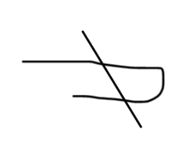

Materials: 5 pieces of string, scissors
Fold a piece of string in half. While it is folded, make 1 cut. See picture below. How many pieces of string do you have? Continue with another piece of string folded in half, make 2 cuts. Then take another piece of string, fold it in half and make 3 cuts… etc… Continue the process and complete the table below.

Table:

# Number of Cuts n | 0 | 1 | 2 | 3 | 4 | 5
# String pieces S

Questions
1. Describe patterns that you observe in the table.

2a. Without cutting the string, use the pattern from the table to determine the number of pieces for 6 cuts, 7 cuts, and then 8 cuts. Describe how you use patterns in the table to do this. [Find more than one way to extend the table.]

2b. Write a function that describes the relationship between the number of cuts , n , and the number of pieces of string, S.

3. It is possible to predict the number of pieces given the number of cuts? Describe in words how to determine the number of pieces for 20 cuts.

4. What if you had 21 pieces, how many cuts did you make? Describe how you solved this problem.

5. Extension: Fold the string like this:
Predict how many pieces you would have if you made 1 cut, 2 cuts, 3 cuts. Verify your predictions by actually cutting string. Build a table of data, and record the patterns that you see in the table. Find the pattern that will predict the number of pieces, if you know the number of cuts.

