By George, what a day for a car show!

A unique show and shine went off without a hitch Sunday in Fort Langley.
Langley Advance
April 30, 2014 04:10 PM
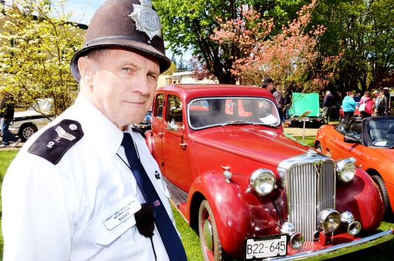
Barry Lafbery purchased his 1949 Rover P3 from a seller on Vancouver Island 14 years ago. Lafbery completely refurbished the car that sat idle from 1964 to 2000. He said he drives the four-speed as much as he can.
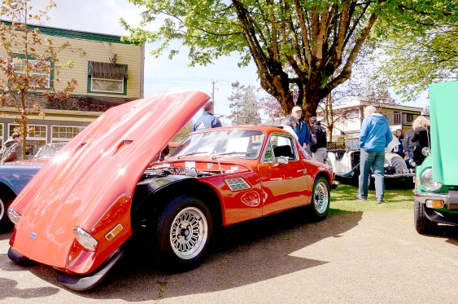
Trevor Heryet’s 1974 TVR 2500M was one of the many impressive models on display during the show
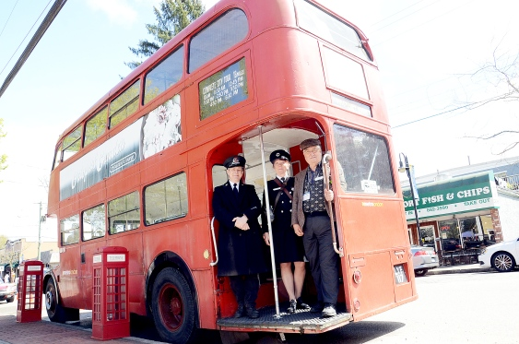
Doreen and Ian Newby joined “conductor” Michael DesMazes stood at the front steps of a 1951 double decker bus used in the film To Sir With Love. The bus was parked along Glover Road for the Langley Area Mostly British Motoring Club (LAMB) St. George’s Day Motoring Show.
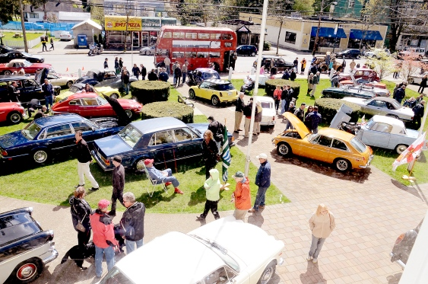
British-made cars and their owners and admirers filled the grounds of the Fort Langley Community Hall on Sunday for the Langley Area Mostly British Motoring Club (LAMB) St. George’s Day Motoring Show
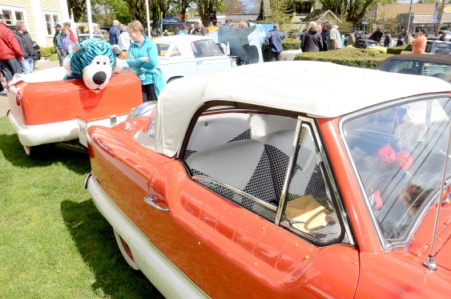
British-made cars and their owners and admirers filled the grounds of the Fort Langley Community Hall on Sunday for the Langley Area Mostly British Motoring Club (LAMB) St. George’s Day Motoring Show
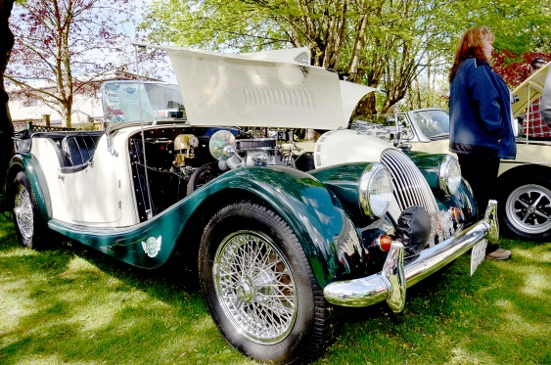
British-made cars and their owners and admirers filled the grounds of the Fort Langley Community Hall on Sunday for the Langley Area Mostly British Motoring Club (LAMB) St. George’s Day Motoring Show
The sun pushed through the clouds mid-day Sunday, April 27, putting smiles on faces of British car owners and enthusiasts who gathered in Fort Langley.
Weather conditions were very agreeable for the annual St. George’s Day Motoring Show, hosted by the Langley Area Mostly British Motoring Club (LAMB).
British-made vehicles filled the front lawn of the Fort Langley Community Hall for the ninth annual show.
Among them: a double decker bus, a 1960 Vauxhall, a 1949 Rover P3, a 1974 TVR 2500M, and a 1968 Triumph TR250, owned by Langley resident Ed Cowx. Cowx and his car were profiled in the Friday April 24 Langley Advance

