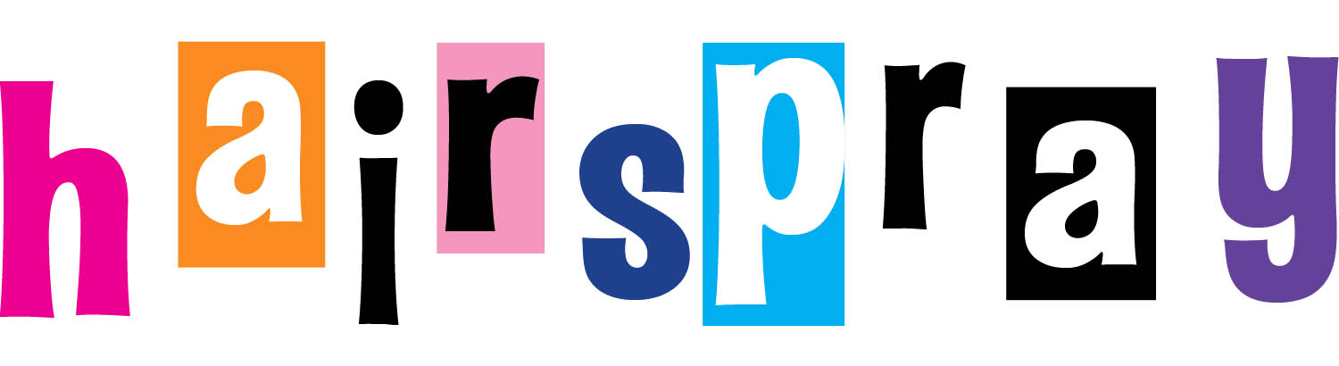

STAGE MANAGER: Wade Jennings

ASSISTANT STAGE MANAGERS: Rebecca Kleinman & Asher Soto

DANCE CAPTAIN/SWING: Erin Alexander

|  |  |
| --- | --- |
| Tracy Turnblad  Madeline Kaye**  (understudy: Molly Bockmeyer)  Velma Von Tussle  Lexi Carter  Amber Von Tussle  Elli Stovall-Brown  Penny Lou Pingleton  Anna Wnukowski  Little Inez  Alexandria Lowery**  Motormouth Maybelle  Fednike Nozistenz**  Corny Collins  Joey Dardano  Link Larkin  Cody C. Goodrich | Edna Turnblad  Tommy Bowe  (understudy: Taylor Rivera)  Wilbur Turnblad  Sam Leopold**  Seaweed J. Stubbs  Cameron Jackson  Dynamites  Paige Jackson  Megan Lewis  Venessa Pierre-Pierre**  Female Authority Figure  Daniella Amador**  Male Authority  Figure  Devon W. Dulaney** |

|  |  |
| --- | --- |
| Council Members  Girls  Rebecca Gil---Tammy  Caroline Johnson**--Brenda  Ally Rosenblum**  Leah Warwick**  Madison Wilcox  Savannah Whetsell--Sherry  Nicole Goewey  Samantha Pollack**--Lou Ann  Boys  Erkki Paunonen--Brad  Kyle Kniseley**  Michael Risco  Taylor Rivera**-I.Q.  Nikolas Polanis**--Fender  Augusto Rocha**  Dennis A. Pozo  Nicholas Galarza**--Sketch  **1ST TIME IN A DSOA MAINSTAGE!!! | Patterson High Students  Girls  Toree Alexandre**  Deontra Palmer**  Venessa Pierre-Pierre**  Anna Drummond**--Lorraine  Megan K. Lewis  Paige Jackson  Rajay Lee**--Cindy  Boys  Jason Burke**  Cheviyante Hill--Duane  Bernard Ofori**--Gilbert  Stephen Santana**  Dondre Tuck*--Thad  Collin Lockett**--Stooey |

*See Mrs. Blanchette

**Never Been In A Dreyfoos Mainstage