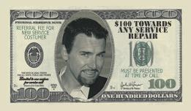
One coupon per service call
Must present this coupon at time service repair that exceeds $300.00

