INDUSTRIAL ACTION

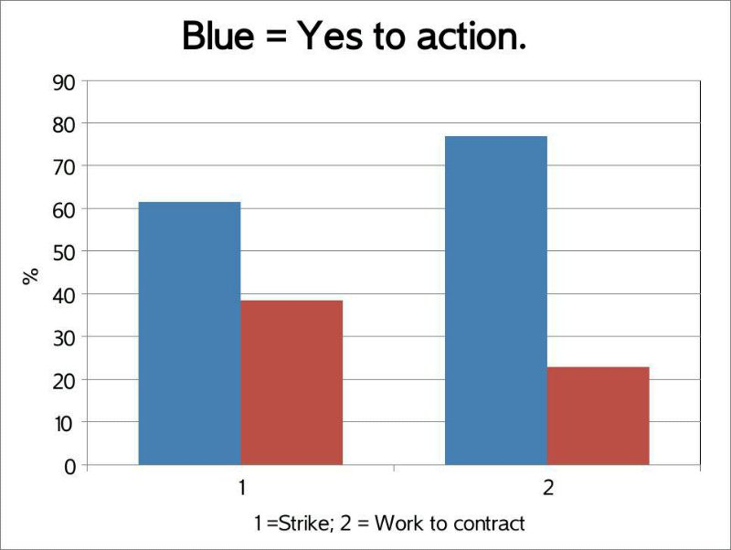
Dear member, of the 21000 members who voted it is clear that we have a clear mandate for industrial action. First let’s deal with government and management spin on this ballot result: governments are elected in the same way and managers are not elected at all!
It is vital at this time that you work rigidly to your contract, which means:
1. If you do not have an agreed work load you are not obliged to do anything.
2. Your agreed work load must be factually correct and not exceed 100%.
3. You must agree with your manager what should not be done if your workload exceeds 100%.
4. You must not work more than 2 sessions a day (9.15-13.15; 13.15-17.15 and 17.15-21.15).
5. You must have a scheduled break of at least 15 minutes between sessions.
6. If you have an evening session, you do not have to teach the following morning session.
7. You do not have to teach more than two evening sessions per week.
8. You must take ALL your annual leave.
9. You should keep a log of your hours and not exceed more than 37 per week, including any evening or weekend marking/preparation etc., with a maximum contact hours averaging 14-18 per week, 550 per year.
10. Travel time for multisite working must be taken into account.
11. Research and scholarly activity does not necessarily require your attendance at the University.
12. You do not have to keep specific office hours as long as you are contactable.
13. Where exceptionally you agree to work beyond your normal contacted hours you should take time off in lieu, agree additional payment or additional holiday.

If you are having difficulty with any issue at the University please contact your local UCU representative; Encourage non-members to join and do the same. The UCU committee will not allow individuals or groups to be treated inappropriately.

It is unfortunate that we have reached this point but so long as we allow both the government and the senior management of Universities to exploit us, they will, whilst at the same time rewarding themselves generously both in terms of individual pay and numbers of staff bloating their levels. It is easy to blame academic staff for senior management failings but the time has come to hold senior management to account and UCU will be communicating separately on this issue.

UCU Branch Committee
Oct 2013

