NEWSLETTER
WINTER 2017
- Work Load
- Research
- Scholarly Activity
- Part-Time Workers
- People & Culture
- Finances

Does your workload make you feel like this?

UCU is increasingly concerned about the impact of workload on staff health and wellbeing. Our advice is:
- Never agree to a workload of more than 100%
- Ensure all contact time with students is on your workload (Lectures, seminars, practical work, tutorials)
- Assessments must be 30mins/student/15CATS max.
- PT staff should have a pro-rata workload.
- Ideally your workload should not exceed 85%
- Take all your annual leave and book it well ahead.
If you have any problems with this or any other issue contact your local UCU representative or the Branch Chair.
Chair | Vice Chair | Secretary | Park Rep. | FCH Rep. | Membership | Website | Equality
Andrew Misiura | Frank Chambers | Pekka Pitkanen | Kevin Walter | Will Large | Melanie Ilic | Martin Randall | Xiaoling Hu

There is an increasing expectation that all academic staff will be engaged in research. UCU has established that the majority of staff are on ‘Teaching and Scholarship’ contracts so HESA does not require these staff to be included for REF purposes. Those on ‘research’ or ‘teaching and research’ contracts should be included. Further, those on exclusively management contracts are not eligible for inclusion. However, there appears to be a mismatch between the nature of the contract and the research output of some staff which will need to be addressed. We have received assurance there will be no ‘teaching only’ contracts.

For the majority of academic staff at UoG the issue is definition of scholarship and how this fits with ‘Research and Scholarly Activity’ (RSA) time and the TEF. The TEF clearly distinguishes between research, scholarship and practice; The term RSA conflates all three. The Higher Education Academy (HEA) and the Higher Education Funding Council for England (HEFCE) cite the Boyer model of scholarly activity which may include: subject updating, curriculum development, conference attendance, consultancy, further qualifications, secondments, applied/practitioner research, research projects as well as more traditional writing for publication. UCU has made very strong representations for staff to be able to engage properly with RSA so this time must be protected from overburdening workloads.
UCU has had continuing concerns about the treatment of some part-time workers particularly in relation to pro-rata workloads, CPD and security of employment. UCU requested data on the number of part-time workers by fraction and school and how long they have been in employment at the university in a similar capacity. Part-time workers cannot be treated less favourably than full-time ones in accordance with The Part-time Workers (Prevention of Less Favorable Treatment) Regulations 2000 and also The Fixed-term Employees (Prevention of Less Favourable Treatment) Regulations 2002 makes specific provision for the limitation of the use of successive fixed term contracts to 4 years of continuous service, after which the contract will become permanent, unless it can be objectively justified not to do so.
The data has revealed that there may be some issues to address and UCU has received assurances from the Director of HR that any anomalies will be fully investigated.

The People and Culture Strategy consultations have been taking place and UCU welcomes the inclusive and meaningful way these have been approached. We now look forward to seeing the emergent themes in the draft report to be published to all staff this month. Following its publication UCU will seek feedback from members.

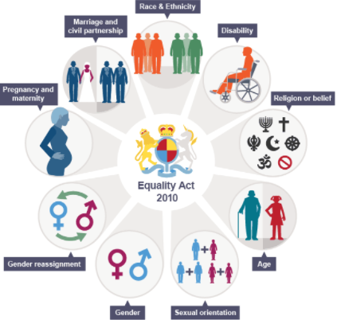
It is unlawful under the Equality Act (2010) to discriminate either directly or indirectly against someone who has one of the 9 protected characteristics. However, UCU has developed a policy statement with the University which means there is no place for any type of less favourable treatment. The University has a dedicated member of the HR team with an equalities brief and UCU now has both the Chair (who sits on the University Equality Committee) and a new committee member Xiaoling Hu with a particular interest in this area. The Chair also sits on the UCU regional executive as the LGBT+ representative.
Within the limits of disclosure, UCU is working with HR to analyse any evidence of inequality in recruitment to the university and treatment of staff and students in any of its provision. It is already clear from the data that there are issues to address with respect to BME staff and women.
A LGBT+ network has been initiated at the University and there is a social event on Wed 29th March 17.30pm – 19.00pm in FW015A and 015B. Please contact Clare Petersen in HR or Andrew Misiura (UCU Chair) for more information.

UCU receives briefings on the state of the universities’ finances and it is part of our responsibility to ask the ‘what if?’ questions. UCU continues to be concerned about the losses associated with INTO and we will press for more information at every opportunity and have asked the university to consider an exit strategy.
In a very competitive market for students, the two options are either to wind up the draw bridge and adopt an austere approach in the hope of riding the market or invest to grow through borrowing. The university has decided on the latter. There is risk either way but it is only proper for UCU to point out that servicing the considerable additional borrowing will seriously erode the projected financial surplus and could put the university in a very precarious condition. The immediate challenge is to increase the conversion rate of applicants in some areas but growth in student numbers is vital or the viability of some courses will be questioned.
All staff policies and procedures are in the process of being updated through the Joint Negotiation Consultation Committee working group on which the UCU Chair sits together with representatives from Heads of School, HR and UNISON. The aim is to make them easier to navigate and in accordance with current legislation. This is a tremendous amount of work and the central principal for UCU is to never agree to any detrimental change but always seek to improve on the minimum required legally. We are pleased with the way negotiations have been proceeding in a very constructive way.
ucuglos is supporting this with a £100 donation.
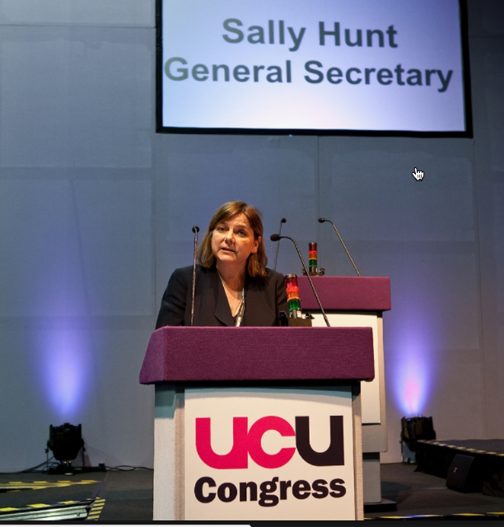 Pekka Pitkanen will be representing ucuglos in Brighton this year. Suggestions for motions to Pekka. We have been reflecting on ‘Trade union identity in a neoliberal right-wing world’.
JOIN UCU to get the help, support and protection you need.
Immigration YOUR CONTRACT
CHANGES: FT/PT/Fraction/Grade/School?
AMEND YOUR MEMBERSHIP RECORD ONLINE AT: https://members.ucu.org.uk/
NEWSLETTER
Winter 2017
UCU Office FCH TC002d

