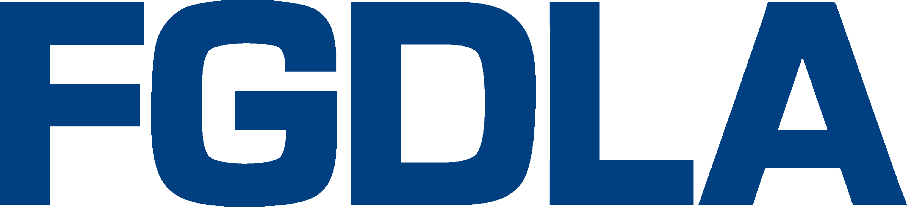

2018 Award Nomination Form
Name of Award (annotate appropriate category…submit for either Organizational or Individual):
Organizational (check one)
Five-Star: : In recognition of an organization for demonstrating leadership and best practices in the development and application of proven distance learning technologies and/or video production supporting distance learning in the Federal Government,
Innovation: In recognition of an organization for demonstrating excellence in the innovative use of technology and/or video-based content in the development and delivery of distance learning in the Federal Government.
Individual (check one)
Pioneer: In recognition of an individual for demonstrating initiative and leadership in the development and implementation of distance learning in the Federal Government.
Hall of Fame: In recognition of an individual who has, over several years, made significant contributions in promoting and developing distance learning in the Federal Government.

Name, Title, e-mail, and Organization of Recipient:

Name, Title, e-mail, and Organization of Nominator:

Description of Qualifying Information:

Please submit your nomination forms to Alex Autry (ajautry@gmail.com) and Jolly Holden (jollyholden@bellsouth.net)
Key Dates: Deadline to Submit Award Nomination: Sep. 21, 2018
Notification of Award: Oct. 5, 2018
Presentation: Thursday, Nov. 29, 2018, 11:45am-1:15pm
Location: Walter E. Washington Convention Center, Washington D.C.
Contacts: If you have questions please call Alex Autry, FGDLA President, 937-904-5479, or Dr. Jolly Holden, FGDLA Executive Director and Government Learning & Technology Symposium Chair, 770-419-2064

