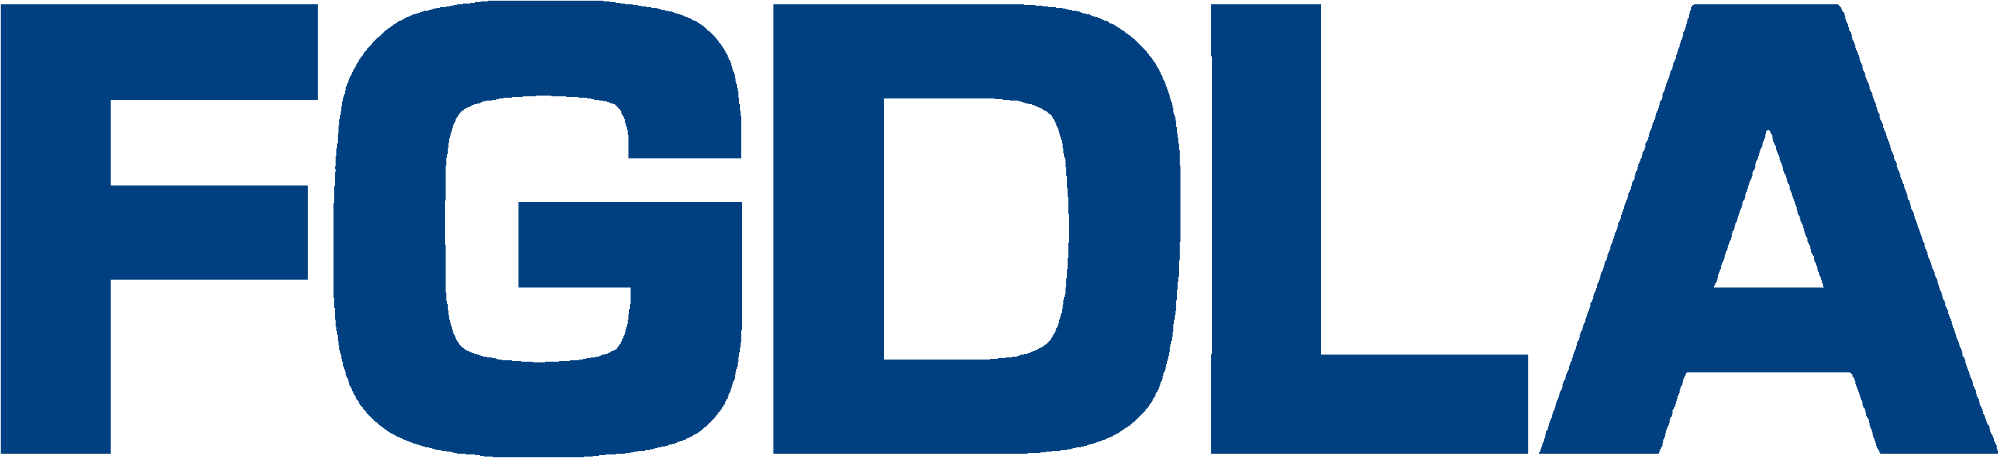

2016 Award Nomination Form
Name of Award (annotate/check appropriate category):
Organizational
Five-Star: : In recognition of an individual or organization for demonstrating leadership and best practices in the development and application of proven distance learning technologies and video production supporting distance learning in the Federal Government,
Innovation: In recognition of an organization for demonstrating excellence in the innovative use of technology and video-based content in the development and delivery of distance learning in the Federal Government.
Individual
Pioneer: In recognition of an individual for demonstrating initiative and leadership in the development and implementation of distance learning in the Federal Government.
Hall of Fame: In recognition of an individual who has, over several years, made significant contributions in promoting and developing distance learning in the Federal Government.

Name, Title, e-mail, and Organization of Recipient:

Name, Title, e-mail, and Organization of Nominator:

Description of Qualifying Information:

Please submit your nomination forms to Alex Autry (Alex.Autry@afit.edu) and Jolly Holden (jollyholden@bellsouth.net)
Key Dates: Deadline to Submit Award Nomination: Sep. 30, 2016
Notification of Award: Oct. 14, 2016
Presentation: Thursday, Dec. 8, 2016
Location: Walter E. Washington Convention Center, Washington D.C.
Contacts: If you have questions please call Alex Autry, FGDLA President, 937-904-5479, or Dr. Jolly Holden, FGDLA Executive Director and Government Learning & Technology Symposium Chair, 770-419-2064

