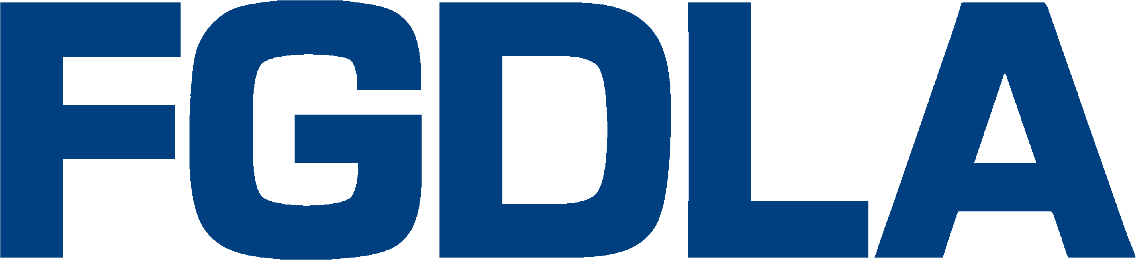

2016 Award Nomination Form
Name of Award (annotate/check appropriate category):
Organizational
Five-Star: In recognition of an organization for demonstrating excellence in providing continuous support of video production and delivery of distance learning in the Federal Government,
Innovation: In recognition of an organization for demonstrating excellence in the innovative use of technology supporting video-based content development and delivery of distance learning in the Federal Government.
Individual
Pioneer: In recognition of an individual for demonstrating initiative and leadership in the development and implementation of distance learning in the Federal Government.
Hall of Fame: In recognition of an individual who has, over several years, made significant contributions in promoting and developing distance learning in the Federal Government.

Name, Title, e-mail, and Organization of Recipient:

Name, Title, e-mail, and Organization of Nominator:

Description of Qualifying Information:

Please submit your nomination forms to Alex Autry (Alex.Autry@afit.edu) and Jolly Holden (jollyholden@bellsouth.net)
Key Dates: Deadline to Submit Award Nomination: Sep. 30, 2016
Notification of Award: Oct. 14, 2016
Presentation: Thursday, Dec. 8, 2016
Location: Walter E. Washington Convention Center, Washington D.C.
Contacts: If you have questions please call Alex Autry, FGDLA President, 937-904-5479, or Dr. Jolly Holden, FGDLA Executive Director and Government Learning & Technology Symposium Chair, 770-419-2064

