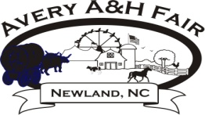
PO Box 790
Newland, NC 28657
828-387-6870
averyfair@yahoo.com averyfair.webstarts.com
Check out our Facebook Page: Avery A&H Fair
Avery County A&H Fair Cross Cut Saw Contest

Mission Statement
Avery A&H Fair is a family oriented mountain fair known for friendliness and preservation
of the mountain heritage that has long been part of the High Country.

Open to all ages
Two person teams
2 minute timed cuts.
A time of 2 minutes will be given to each team.
The team with the best score each night will advance to the cut off on Saturday
$1.00 to cut for fun
$ 5.00 to cut for competition
Prizes will be awarded each night to the longest cut.
Prizes will be awarded on Saturday.

Times: 5:00 until 9:00 (Tues thru Fri)
Saturday’s competition will begin at 6:00 pm

Name_____________________________________________________________________________________
Name____________________________________________________________________________________
Address___________________________________________________________________________________
City______________________________State__________________________Zip Code___________________
Phone Number___________________________ Cut For (Please Check One): Fun_______Competetion______

