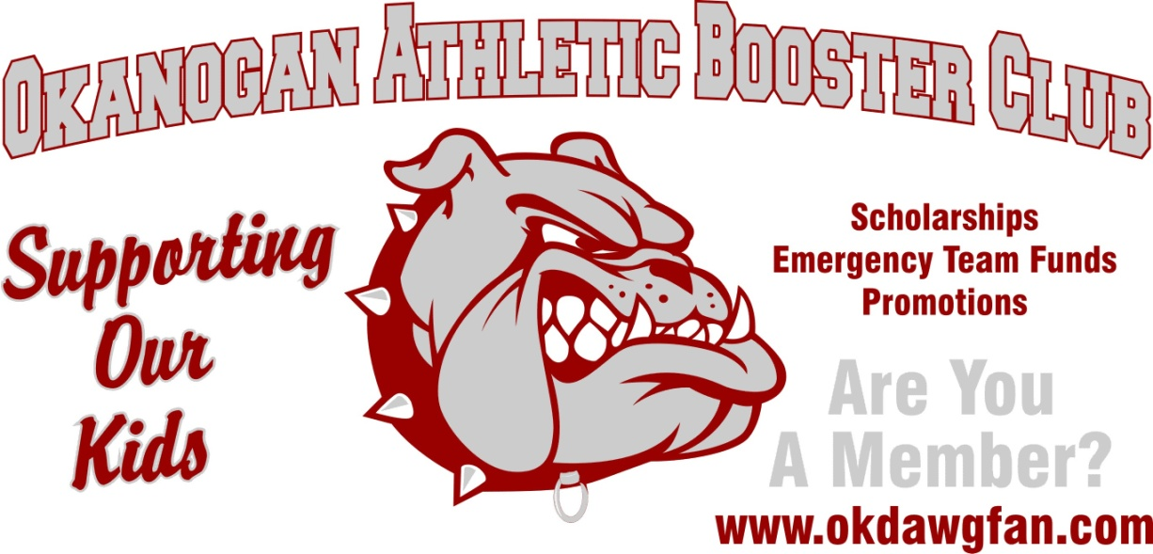

Scholarship Application Form

Name:
Last, First, Middle

Permanent Address:

Street or PO Box, City, State, Zip

Home Phone #: Other Phone #:

Accumulative GPA: (Please attach official transcript)

Name of College/University in which you plan to enroll:

Have you been accepted? Yes / No

What is your intended field of study?

Extracurricular Activities:

Leadership Positions Held:

Work / Volunteer / Community Service Experience:

Qualifications:
Transcript; showing 3.0 GPA or better
NO athletic infraction senior year
Two sport athlete senior year
Personal Essay: Our Booster Club is committed to supporting our student athletes and athletic programs at OHS. Teamwork, sportsmanship, expectations, and responsibility are all positive traits gained through athletics and if done right helps our student athletes succeed in life. Please share with the OABC how an extracurricular activity at Okanogan High School has benefited you with life skills and experiences.
Deadline: Friday May 11, 2018 @ 3:00pm
Forms may be turned into the Okanogan High School counselors or any OABC board member.

(please feel free to add and use additional papers to complete this application)

