1. Go to http://printable-coupons.blogspot.com/ Click Printable Coupons > Retail

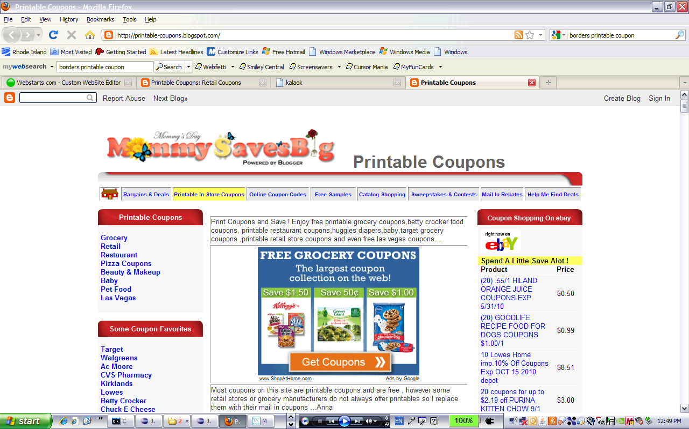

2. Find Retail Store list , Click “AC Moore”

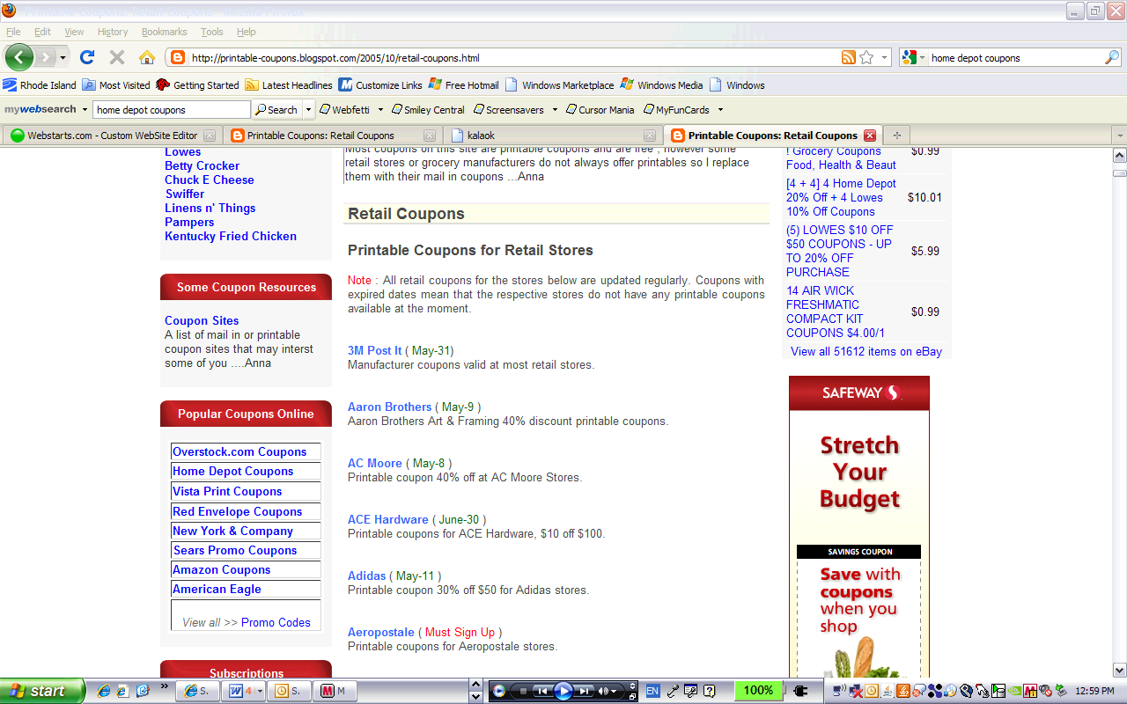

3. Click “ AC Moore Coupons”

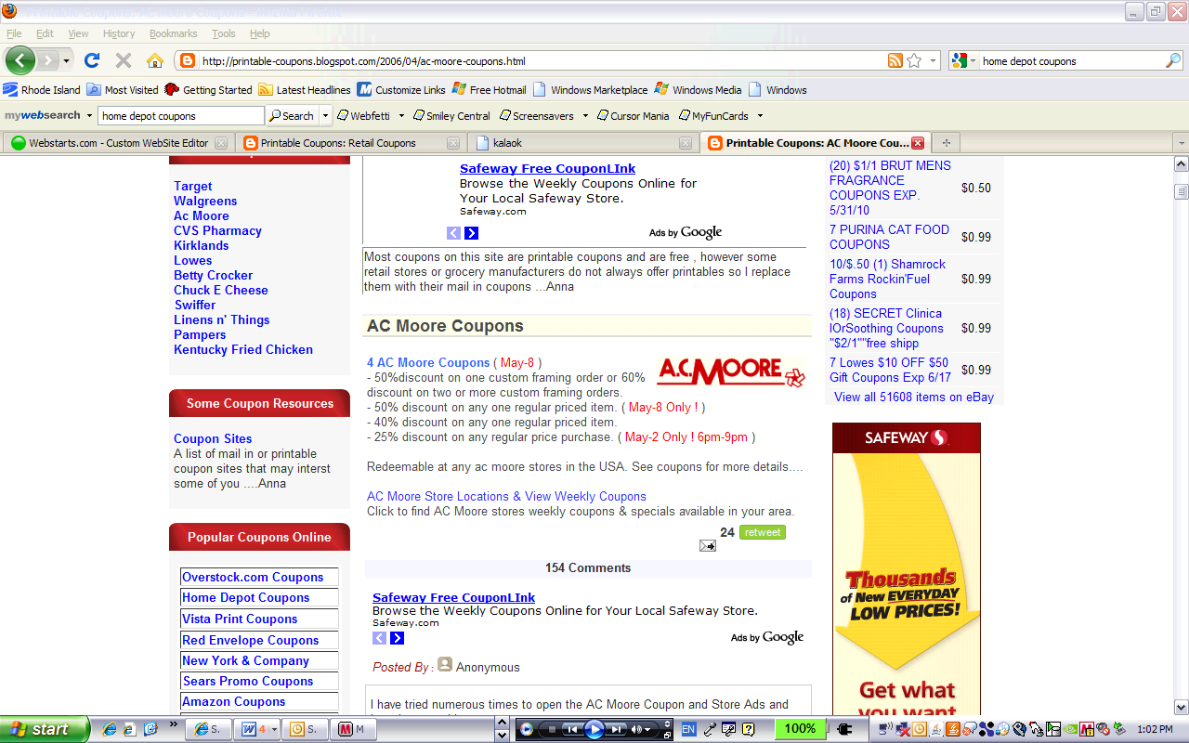

4. Print Coupon

