Women of Australia Blog

Aboriginal Woman

My name is Barbara Tjikatu and I live with my husband Johnny in the outback of Australia on the Uluru-Kata Tjuta National Park; the white men call the park Uluru or Ayers Rock. Australia is the largest island in the world and is located below Papa New Guinea and Indonesia, above New Zealand and surrounded by the Indian and Pacific Oceans.
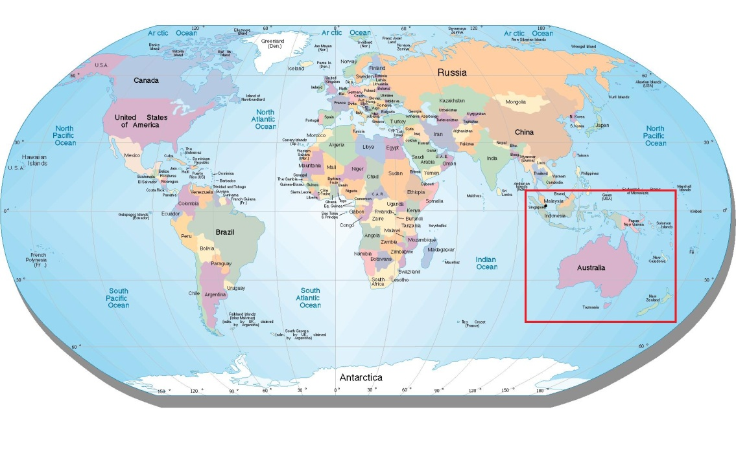

I am on the board of management for the park and I spend most of my days painting artwork for us to sell to the white men who visit our park. My ancestors inhabited this land for thousands of years before the white man came and killed off many and pushed most of us out of the lands we cared for, for all those years. Before the white man, my ancestors would live on the bush food. We ate native berries, fruits and nectars and hunted the wild kangaroos, wallabies and emu. We did not stay in one place too long though as the weather in Uluru can get very hot. Many tourists die each year trying to get here for a visit.

Growing up, my mother told me of the Tjukurpa (pronounced choo-koo-pa) stories for me to carry on to my children. The white men call the Tjukurpa Dreamtime; even though we know it was not a dream. The Tjukurpa tells my people of our Anangu religion, laws and moral systems. Tjukurpa explains our past, present and future and how our ancestral beings created our world a long time ago. Tjukurpa educates my people about the relationship between humans, plants, animals and the physical features of the land.

Tjukurpa is very important to my people. We do not write it down because we pass it down through generations orally through stories only to those worthy of knowing it. Unfortunately, I was unable to pass my stories down to my children because they were taken away from me when they were very young.

You see, once the white man named Captain Cook claimed Australia in 1770, the white man said my people were not civilized and so they took our lands and killed our people. This does not surprise me as these white men were all convicts that Great Britain sent to live here to make room for the civilized white man in Great Britain. From 1910 to 1970, they stole our children away from us because they said we did not have the right to put our Tjukurpa stories into their minds.

Of the 100,000 children stolen from their families, my children Kulitja and Tjingo were two of them. I have not seen my children since they were very small and wait for the day when we will be reunited once again. Two years ago, the nation’s prime minister, Kevin Rudd, made a formal government apology to my people for their actions but it does not change the fact that I never knew my own children.

For these reasons, I do not trust the white man; even though I make them artwork and let them visit Uluru. If I had the choice, this land would go back to its sacred origins and be only viewed and used by my people who cared for it all those years. Because of what the white man did to my people, any man who steals sand from our sacred grounds will be cursed until the land they stole is return to us. For this reason, we receive rocks and sand every year from tourists who stole from our sacred grounds and angered our ancestral beings.

While my people still have a sacred connection with our lands, we do not move with the seasons as our ancestors once did and therefore we eat like the white man. Much of our diet consists of beef, fruits and vegetables. The problem is that since we do not move with the seasons anymore, the white man sends us our foods a few times a month.

Big trucks drive far distances and through dangerous deserts to come to our local grocery store and give us supplies. The white man brings cattle meat, fruits and vegetables from the lands of farms and water since we have no access to fresh water in the Outback.

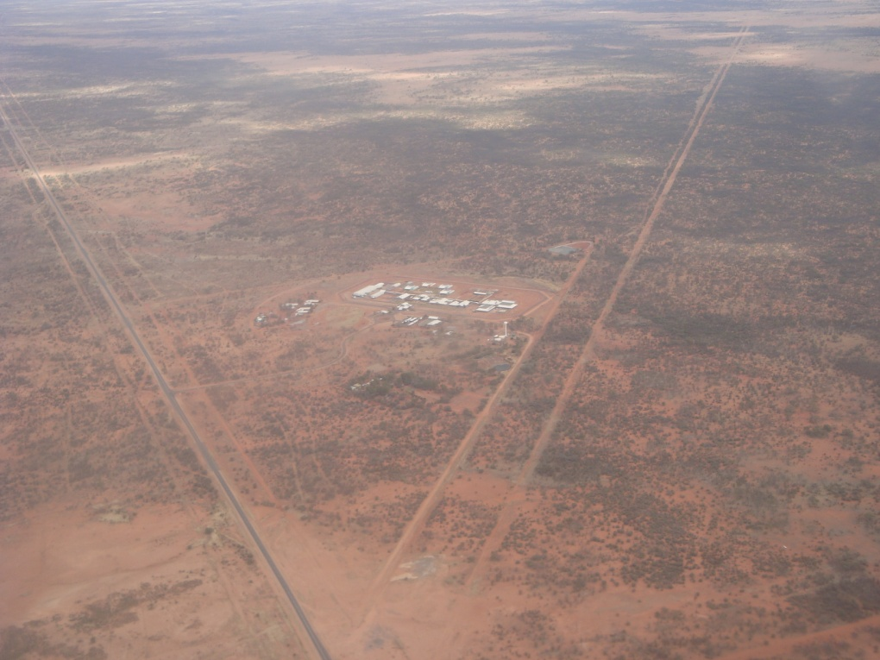

The white man brings us clean water because we only get rain once a year if we are lucky and live in a permanent drought; most years we only get 2 inches of rainfall. The white man also brings us cattle meat because we cannot keep cattle in the desert because there is nothing for them to eat here; we do not eat bush meat like we used to because the white man’s food from Europe is more accessible. He also brings us fruits and vegetables because we cannot grow them in these temperatures which can reach 105°F on summer days and 68°F on winter nights.

After my husband and I buy the groceries we need for the week from the store, we bring them home and we each enjoy making meals for each other. We enjoy making our meals and we never go out to eat. This is for a few reasons; we do not like to visit the white man’s businesses and because we do not have access to restaurants due to the fact that we live in such small communities. We are sustained by tourism and selling our artwork.

My story might be a sad one, but it is my own and I am happy to share it with you.

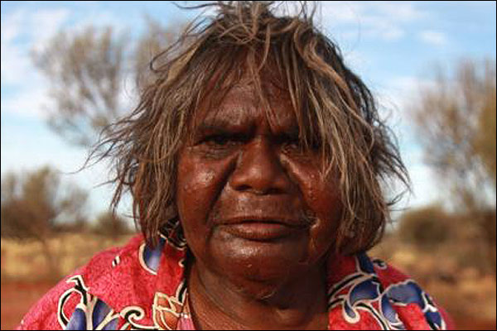

Modern Day Australian Women

My name is Jennifer Ross and I live in Sydney of New South Wales. I am 24 years old and live with my mother while working at the grocery store Woolworths (Australian’s call it Woolies) and go to Uni. Our family migrated from New Zealand (a small country right below Australia) when I was 7 and I have lived here ever since; I have citizenship in both countries. Australia is very nice for a variety of reasons but one very important reason is because I have many opportunities as a woman.

I can move freely within my country and have the opportunity of public transportation which can take me from one end of my country to the other. In fact, in 1902 women in Australia were the first in the modern world to gain the right to vote in national elections and be elected into parliament and we also have the right to practice any religion we decide although I do not have a religion I practice myself, like many of my friends. The sad part of this story is that aboriginal women of my country were not given the same rights until 62 years later in 1964.

A few years ago, I got pregnant with my boyfriends child and luckily I was able to get an abortion as it would have been an economic hardship on me because I was leaving him for his abusive behavior which is not uncommon in my country. You see, 1 in 3 Australian women will have an abortion, 46% of Australian women report physical violence and 34% report sexual violence. I am not sure why these numbers are so high, especially the abortion rates because 76% of Australian women use contraceptives and 100% of Australian women have access to them.

I feel lucky to have been able to make that decision for myself as many other Australian women are unable to get an abortion unless it is life-threatening. You see, the 6 states of my country do not get along and therefore there is no one set of rules; we all make our own rules individually as separate states. Our political system has a capital (Canberra, not too far from where I live) but we are still under British rule even though we gained independence in 1987. We make our own laws, but England sees over what we do and helps us make decisions.

We have a very good economical system as well here in Australia. We do not import foods and we usually only export foods to New Zealand because they are so close to us. We sustain ourselves by growing our own fruits and vegetables and maintaining our own cattle; 90% of all our cattle is used for beef. It is very nice because all our foods are local and healthy. We have many farms and grazing lands all over our coastlines and inlands (just not in the deserts) where we raise cattle and grow crops. Our family farmers are still prevalent in our country and use many of the traditional farming methods they brought over with them from Britain such as using herd dogs.

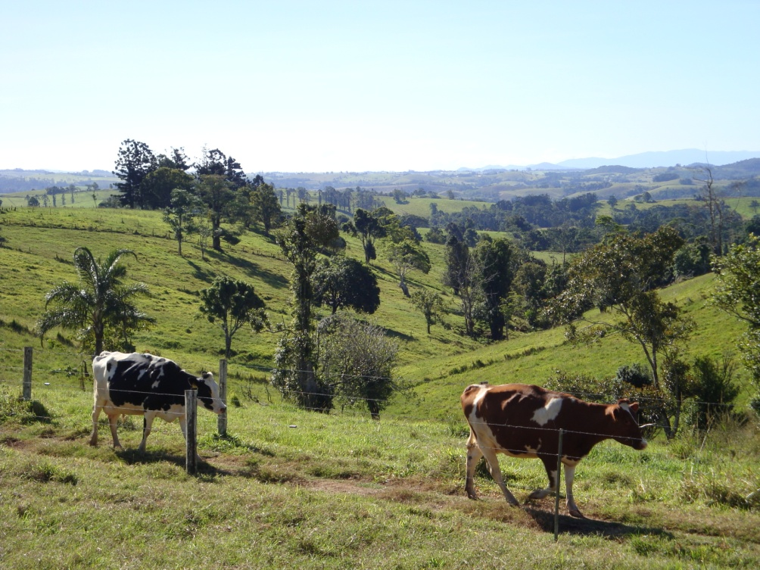

With changing times, it is becoming more difficult for our 370,000 farmers to make enough money to sustain themselves as farmers. However, “despite all the changes in Australian farming over the centuries, there is still a strong sense of tradition and pride among Australian farmers today and many of the old-fashioned values of farming are as strong as ever for Australian farming families” (culture.gov.au). I feel proud to live in a country who sticks to their traditions.

For this reason, I feel proud to sell the cattle meats that are available to the public at Woolies. I am also proud to sell our fruits and vegetables which I know are local and fresh. Our slogan for Woolies is “We Are The Fresh Food People” which is very true.

It is also nice to know that our country is not so far into debt that we will never get out. We are $403 billion in debt but this is not too much considering we have a trade surplus which means we export more than we import (we make more money than we spend). Also, the unemployment rate is only 5.8%. So when you consider those who do not want jobs, this number is very good.

As a front desk clerk at Woolies I make $18 per hour (minimum wage), only work 25 hours a week (30 hours a week is full-time here in Australia), get 4 weeks of paid vacation every year (mandated by the government for all part-time and full-time employees) and have government health insurance. This makes it very easy for me to pay my way through Uni to get a degree, have an ample amount of time off and not have to worry about paying for health insurance. For this reason many Australian’s, including myself, love to travel the world as we have the time and money to do so.

Australia is very unique and diverse in its regions. We have six states and every state has its own weather patterns and lands. When I lived on the Gold Coast of Queensland for instance, mountains, waterfalls and dormant volcanoes made up the landscape of my area and could be reached in 20 minutes while you could see the beach from my apartment window which was less than 5 minutes away. Most regions have ample farmlands and diverse landscapes. Yet we all face the possibility of bushfires, drought, global warming, dust storms and cyclones.

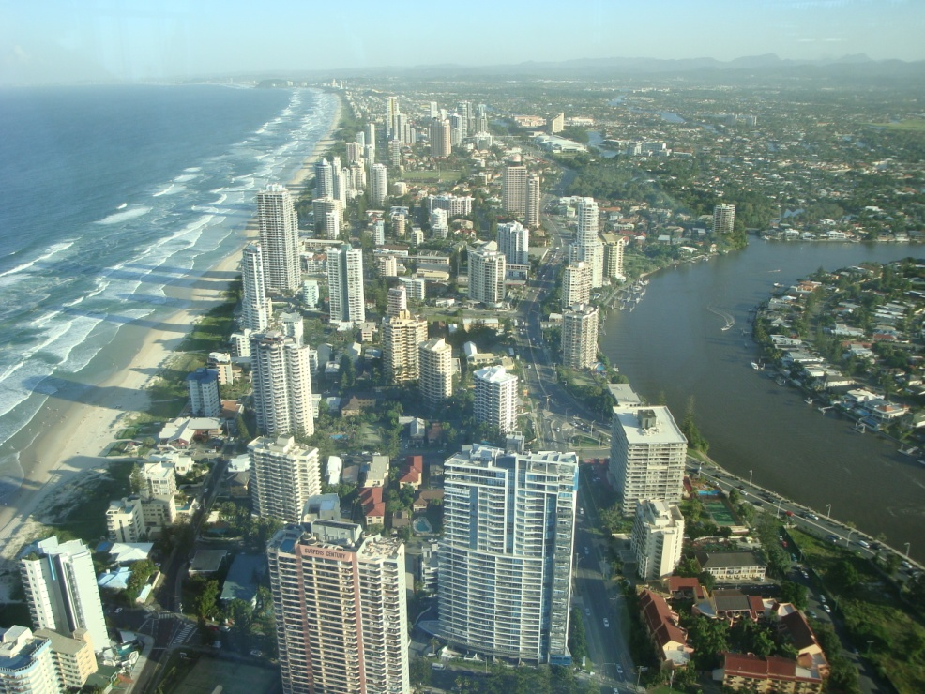

One thing all our regions have in common is that we live in drought because of the limited rainfall we get each year. While my region may get around 11 inches of rainfall per year, some regions may only get 1 or 2 inches of rainfall if they are lucky. How much rain we get determines how much crops we get for the year and how much crops we are able to send to our desert regions.

With all our available vegetation and cattle, we are a highly commercialized area. For the most part, Australian’s live in areas like I do. There are 6 states and each state has a major city in which people congregate. We enjoy public transportation, big buildings, grocery stores, large shopping malls, running water, restaurants, etc…

I am glad that you have taken the time to listen to my story. Maybe one day you will visit my country to see this beautiful land for yourself.

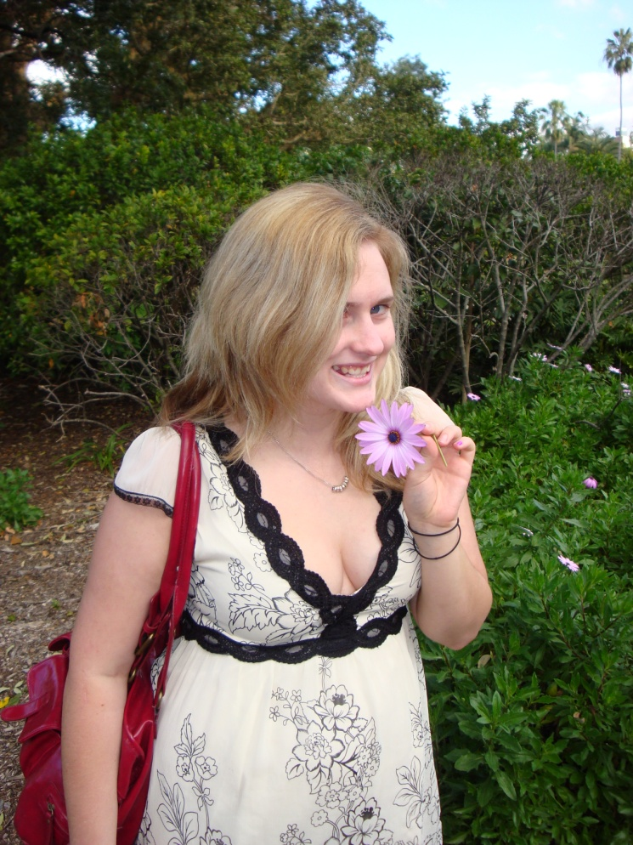

Other Australia Facts

Status of Women

- Life Expectancy:
  - Men: 79
  - Women: 84
* Proportionately lower for Aboriginals
- Literacy Rate – 99.0%
* Lower for Aboriginals
- Fertility Rate – 1.81 babies per woman (2005)
  - Indigenous Women – 2.06 babies per woman (2005)
- Birth Rate - 12.47 births/1,000 population
- Mortality Rate – 6.68 deaths/1,000 population
- 1 in 3 women will have an abortion
- 21% of women will have a teen pregnancy
- 76% of women use contraceptives
- Only 0.1% of Australian’s are living with HIV/AIDS
- 48% of Australian women report experiencing at least one incident of physical violence over their lifetime
* Rates are much higher for Aboriginal women
- 34% report experiencing at least one incident of sexual violence over their lifetime
* Rates are much higher for Aboriginal women

Exports and Imports

- Indigenous Cattle Meat is their main commodity
- Cattle was introduced in 1793 with the first European settlement
- 90% of all cattle are used for beef
- Trade Surplus
- Major Exports:
  - Coal
  - Iron Ore
  - Natural Gas
  - Gold
- Major Imports:
  - Petroluem
  - Motor Vehicles
  - Gold
  - Medicines
- Main Exporters:
  - Japan
  - China
  - Korea
  - India
- Main Importers:
  - China
  - US
  - Japan
  - Singapore

Debt Status

- Member of IMF
- $403 Billion in debt
- GDP - $1.1 Trillion
- Unemployment Rate – 5.8%

Statistics

- Religions
  - Anglican 26%
  - Protestant 17%
  - Roman Catholic 26%
- 15% of Australian’s consume alcohol in high risk amounts

