THE EVERCHANGING BODY IMAGE AND POWER

INTRODUCTION

While reading the numerous texts regarding culture and different cultural practices in Cultural Theory In Everyday Practice by Nicole Anderson and Katrina Schlunke, I couldn’t help but thinking on several occasions about the body and social standards of the body across different cultures and across time (past and present). The idea that cultures ingrain into the minds of its participants the fact that a particular body image is that of the norm is a very interesting subject within itself. Due to this intrigue, I decided to study the subject a little further.

First of all, it must be noted that many ideas are not accepted worldwide and do not remain static across time due to the fact that ideas and realities are constantly changing because they are contingent on the current era of time, political stance, economic state, etc in which the ideas are formed. As a result, what one believes to be the norm in one period of time within one culture can be completely opposite what another believes to be the norm in a different culture, within a different time period and even the same time period. Therefore, what is “normal” and how can there be a “normal” if two individuals believe “normal” are two separate ideas?

I would like to further apply this idea to the concept of the “normal” body across cultures and time and what body type is seen as being beautiful. Are we born knowing what the ideal beauty is or are we conditioned to recognize those ideas forced upon us by society as to what the true idea of “normal” and beauty is ( I will re-address this question later on)? Let’s start with looking at the ideal body image as it has changed throughout recent history.

BODY IMAGE, BEAUTY AND CULTURAL PRACTICES

CHANGES THROUGHOUT RECENT HISTORY

Above Left: The Three Graces by Peter Paul Rubens (circa 1620) – Baroque Era

Above Right: Marilyn Monroe (circa 1950’s) who is now referred to as the modern day sex symbol and an average sized woman

Left: A modern day runway model sometimes referred to as a live “hanger” (circa 2000’s)

When looking at these pictures, it is easy to see that the ideal body image has undoubtedly changed throughout history to coincide with ever-changing cultures and cultural practices. While these are just examples of the more obvious changes the ideal/normal body images has undergone, there are more extreme measures of beauty which have been observed throughout history as well.

Some extreme measures of changing ones appearance in the name of beauty which many westerners may see as tortuous, inhumane, barbaric, disgusting and/or cruel include the wearing of corsets, foot binding and the elongation of the neck all in the name of beauty.

DIFFERNCES AMONG CULTURAL PRACTICES
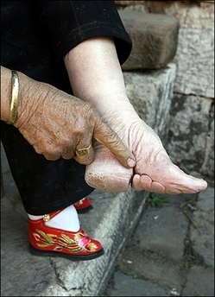
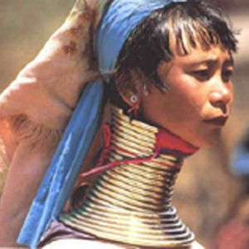

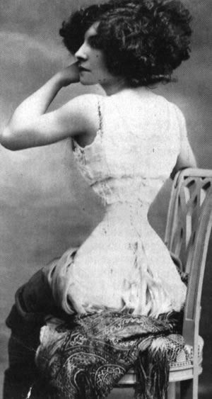

Above Left: A Kayan woman wearing neck rings to push down her collar bone, ribs and shoulders to provide the illusion of an elongated neck

Above Right: A Chinese woman shows off the effect of her foot binding

Left: Polaire proudly showing off he much sought after 14 inch waist (35.5 cm)

Historical Corsets: During the 18th century, corsets were worn to give the illusion that a woman had an hourglass figure. Essentially, the corset took the body and redistributed the organs around the waistline and gave the illusion that a woman had a small waist and larger hips and bust. Unfortunately, women who wore these corsets were in fact subjected to an array of medical problems including fainting, organ damage and lack of abdominal and skeletal support (your corset became your support). If this was risked to in order for women to achieve the much sought after hourglass figure in which their society/culture placed emphasis on during this era. (Wikipedia)

Chinese Foot Binding: “A bandage, ten feet long and two inches wide was wrapped tightly around the foot, forcing the four small toes under the sole of the foot. This made the feet narrower but at the same time it made the feet shorter because it also forced the big toe and the heel closer together by bowing the arch of the foot. The bandage was tightened each day and the girl was put into progressively smaller and smaller sized shoes. The entire process usually took about two years at the end of which the feet were essentially dead and utterly useless.” (Crites) Nonetheless, Chinese foot binding was “viewed as a source of beauty and pleasure” until it was outlawed in 1949 and proves how “immense human suffering can be inflicted in the pursuit of female beauty.” (Wikipedia) This sacrifice of an able bodied female woman was also seen as a social status; they could sacrifice a family member to status rather than having them work in the fields. It later was regulated by the government and it was impossible for a woman to marry if her feet were not bound due to the fact that the government used the match-making system and women were not eligible if their feet were not bound.

Kayan Neck Elongation: “The custom of wearing neck rings is related to an ideal of beauty: an elongated neck. Neck rings push the collarbone and ribs down. The neck stretching is mostly illusory; the weight of the rings twists the collar bone and eventually the upper ribs to create the illusion of an elongated neck. The vertebrae do not elongate.” (Wikipedia)

Many of these practices have been around for a very long time allowing these social customs to be perceived as the norm to the particular society in which the custom is practiced. “The practice of foot binding lasted for approximately one thousand years. During this time, approximately one billion women had their feet bound” (Crites) and the art of neck elongation has been around for over 700 years as well.

A NEW PERSPECTIVE

Before we condemn these practices as being barbaric, we must first take a step back and deconstruct our learned preconceived notions of what is “normal” and acceptable within our own society. For example: what is the difference between these extreme practices being performed in the name of the “ideal” body image and that of western society who is more and more accepting of plastic surgery which attempts to “correct” those aspects of the body in which the individual feels is not up to par with that of the socially acceptable image? What about those women who desperately seek to fit into the socially constructed western idea of the “normal” body image and default to anorexia and/or bulimia to strive for the build of a 125 pound (56 kg) woman? The answer is that there is no difference.

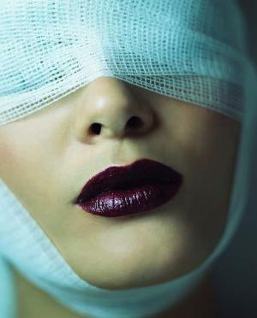
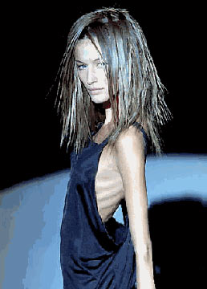

Left: Anorexic woman posing

Right: Woman undergoing plastic surgery to look more like the “ideal/normal” image of beauty

It is a little hypocritical to automatically assume that our practices within our culture are acceptable and those practices of individuals within culture not of our own are barbaric, when in fact, they are no different. Have you ever wondered what individuals a few hundred years from now will think when they research our modern day western culture’s body image and see breast augmentation, nose jobs, face lifts, liposuction, etc? It is most certain that our culture will be scrutinized in the ways we judge other cultural practices.

We must, as Anderson states, “make the familiar strange and the strange familiar” in order to understand the difference across cultures. Meaning, that before judging and condemning cultural practices that may seem foreign to us, we must identify why these ideas could be in place.

Take for example the picture of the woman from the baroque era and the modern day runway model woman. Think for a second about why these two women‘s ideas of why a “normal” and beautiful body are so drastically different. If you take into account the aspects of each woman’s culture (politics, economics, etc…) you might realize why these two images are opposite one another.

The woman from the classical era may be seen as beautiful because it may show/prove that in a time of famine, she was not of those starving. Therefore, her idea of beauty was that of a full figured woman who could afford to eat and held a higher social status. We can also analyze the anorexic woman’s idea of beauty from her cultural view as well. Anderson explains in the introduction that those within western societies are considered privileged if they are able to take time out of their day to exercise and stay physically fit during a time of recession; whereas most people have to work 50+ hours a week just to make ends meet. Therefore, the woman who is skinny might be seen as more privileged within her society.

BEAUTY AND BODY IMAGE REGUTLATED BY POWER

Now, I will come back to the questions I proposed in the introduction. (1) What is “normal” and how can there be a “normal” if two individuals believe “normal” are two separate ideas and (2) are we born knowing what the ideal beauty is or are we conditioned to recognize those ideas forced upon us by society as to what the true idea of “normal” and beauty is?

The first question can be answered using common sense. If we are told that the “normal” body image is one thing and an individual of another culture is told that the “normal” body image is something different, then one must assume that the “normal” body image is purely contextual to their own culture. Meaning that there is no universal “normal” because what is “normal” is completely contingent on the individual. Therefore, one must conclude that there is no true meaning of “normal” (especially while considering the norm of body image) when the idea of this “normal” socially constructed body image changes across time and cultures.

The second question can be answered by reverting back to the text by Nicole Anderson The Stories So Far: Part 1 which uses ideas of self-surveillance/governance of the body to explain these changes. “Every society has modes by which people come to know and govern themselves… Foucault demonstrates the way in which power and knowledge in modern society are carried out by individuals on themselves. In modern society, self-surveillance is a modern disciplinary technique that regulates bodies” and may “take the form of the surveillance of our own appearance (fashion). This modern surveillance is a means by which to create “normal” bodies.”

But, who implements these ideas into citizens of a culture and tells them what idea of a “normal” body to achieve via this self-governance? Today’s society can be used as an explanation through the use of media which is controlled by the government who contains the power of its people. This “occurs through the influence of those in the position to have their ideas circulated and cemented” which is also known as the government. One can see this when thinking about the fact that in today’s modern society, the media is who promotes this self-governance to those within its culture to stay thin, build muscle, whiten their teeth, dye their hair, stop the aging process and stay young looking. So, one might believe that the media is who drives this image of “normal” and tells us what we should strive for. However, who regulates the media? The government…

Therefore, when you think about the idea that we are taught to regulate ourselves by the media and the media is controlled by the government, this proves that we are in fact told how to control our bodies by our very own government. While one might think that this self-governance is purely voluntary and proves ones freedom of choice, does it not also prove that the government in fact controls those aspects of our life in which we are conditioned to believe (once again by the media/government) are those aspects of our life are what make us individual and hence allow us to be free. But, one might argue (myself included) that the government instructing us how to be individual only reinforces their power over us.

CONCLUSION

What this means is that while body images and the “normal” body image changes throughout time and culture, it is regulated by those who perform these rituals (the individual) who are told by society (media) what to achieve who is ultimately regulated by the government. Therefore even as we are deciding for ourselves how to be individual, the government has provided the image of what individuality is. Therefore, beauty, body image, “normal”, etc are all regulated and produced by the government and therefore everyone within that society is subject to its power, even as we are condition by the very institution that provides us with these ideas to think otherwise and answers to the question that we are in fact not born knowing of beauty but taught what beauty is and this is why beauty, body image and the idea of a “normal” body changes across time and cultures.

SOURCES

http://www.staylace.com/gallery/gallery05/polaire/index.html Retrieved Friday April 10th 6:50PM
http://en.wikipedia.org/wiki/Foot_binding Retrieved Friday April 10th 6:50PM

http://www.angelfire.com/ca/beekeeper/foot.html James A. Crites (Written 25 October 1995) Retrieved Friday April 10th 6:50PM

http://xmb.stuffucanuse.com/xmb/viewthread.php?action=attachment&tid=3749&pid=11011 Retrieved Friday April 10th 6:50PM

http://en.wikipedia.org/wiki/Neck_ring Retrieved Friday April 10th 6:50PM

http://news.softpedia.com/images/news2/The-Giraffe-Women-of-the-Neck-Rings-2.jpg Retrieved Friday April 10th 6:50PM

http://www.esramada.pt/pt/alunos/alimsau/images/anorexia3.jpg Retrieved Friday April 10th 6:50PM

http://vrlab.epfl.ch/~thalmann/marilyn.jpg

http://www.citizenarcane.com/files/2005/April/19/rubens_three_graces.jpg

http://www.ocaiw.com/galleria_niah/gallery.php?author=623&id=101

