To enter for the full 12 months, please hand in completed forms with payment to your coach by Thursday, 12/2/2015,
If posting subscription form with payment, please post to:
Largs Gymnastics Club 50/50, c/o Allan McKinnon, sportscotland National Centre, Inverclyde, Burnside Road, Largs, KA30 8RW
Questions to olestacey@googlemail.com
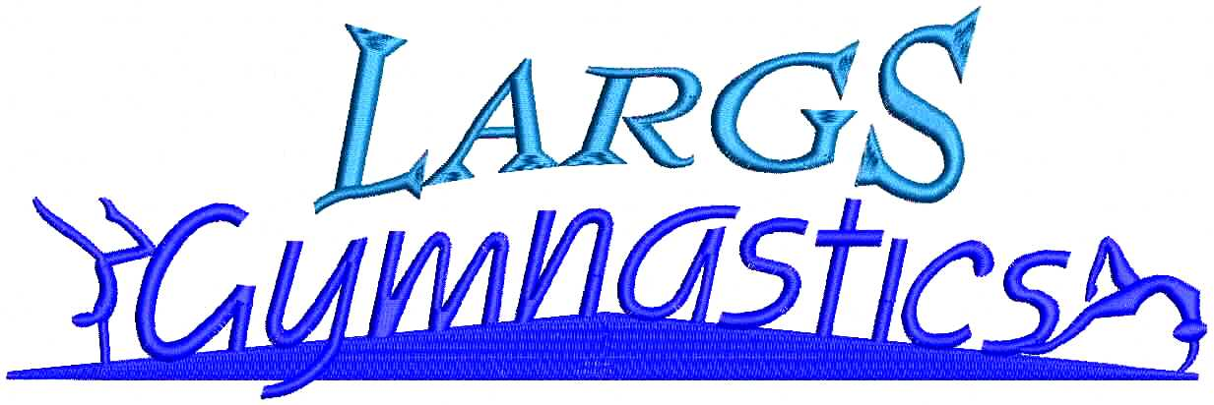

50/50 Club Subscription Form

Name…………………………………………………………………………………………………………………..

Address………………………………………………………………………………………………………………..

………………………………………………………………………Post Code………………………………………

*E-mail………………. …………………………………………………………………(*Email is our preferred method to contact you)

Home Telephone……………………………………Mobile…………………………………….……………………

If you know a club gymnast and trust him/her to deliver a cheque to you should you win,
please write his/her name here…………………………………………………………………………………………

I would like to buy ( ) number(s) at £1 per month. Please return this completed subscription form with full annual payment. Annual payment is £12 per number. If paying by cheque, please make payable to ‘Largs Gymnastics Club’.

50/50 Club Rules

1. The Club shall be known as the Largs Gymnastics Club 50/50 Club.
2. Each number purchased will cost £1 per month and the subscription is for 12 months. Subscribers are required to pay a year’s subscription (per number) in the form of cash or cheque of £12.
3. The subscription year runs from February to January. You may join in the middle of the subscription year. If you are joining before the 10th day of the month, you may include that month’s draw in your subscription price.
4. All paid numbers will be entered into a monthly draw and a winning number will be drawn at random usually at the monthly committee meeting in the presence of at least two members of the committee.
5. Any subscription with a cheque returned unpaid by the bank will not be a member of the club and not eligible for the prize draw until subscription is paid.
6. 50% of the monthly income will be used to benefit the club and 50% shall be distributed as prize money. Once 100 numbers have been sold, there will be three prizes. The prize money will be divided as follows: 1st prize, 50%; 2nd prize, 30%; & 3rd prize, 20%. If we do not reach 100 members, there will only be 1st prize, which is 50% of the monthly income.
7. Notice of each month’s winners will appear on gym hall notice board and on the Largs Gymnastics Club website. We will also contact winners by e-mail or telephone to discuss delivery of winning cheque(s).
8. Cheques will be issued to the winners and delivered either by a registered gymnast specified above, collection in person or if this not possible, by post.
9. The decisions of the Largs Gymnastics Club Committee are final. The committee shall have the power to amend these rules at their discretion and advise these changes to members on the Largs Gymnastics Club website.
10. All subscriptions are non-refundable.
11. Upon receipt of paid subscriptions, the committee will issue you with your number by e-mail or by post. All numbers will be recorded in Largs Gymnastics Club 50/50 log.

By signing this form, I am agreeing to the above mentioned rules and confirm that I am of age 18 or older.

Signed……………………………………………………….……… Date………………………….………………

Club use only
Form received on ______________

Number(s) assigned ______________

