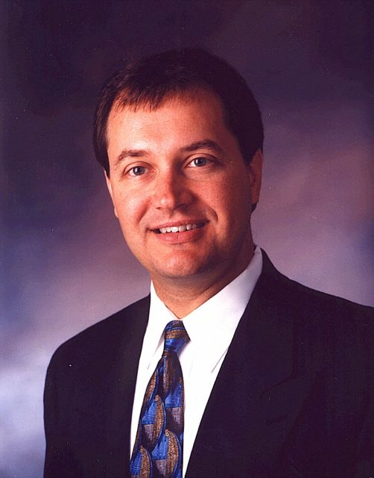
Glen E. Horecky, RFC, CSA
Mr. Horecky is president of Wealth Design, LLC, a financial engineering firm having unique expertise in risk management, tax planning, and the design of proprietary financial structures.
Mr. Horecky brings more than 30 years experience in the design of advanced financial transactions for individuals and businesses of substantial net worth. Mr. Horecky is often brought in as a member of a team of professionals who advise clients on the integration of legal, financial, and tax planning matters.
Mr. Horecky’s previous professional experience includes:

- Executive Vice President of JCA Financial Services, subsidiary of a regional Investment Banking firm. Mr. Horecky was responsible for the development and operation of the Planning Services Division.

- Staff Financial Consultant with a prominent Palm Beach county Law Firm.

- Director of Estate Planning of a branch of a national Stock Brokerage firm.

- President of Interlink Services, Ltd., a Bahamas based International Financial Advisory firm specializing in offshore investment management and international tax planning.

- Host of a daily Radio Talk Show broadcast throughout south Florida, and a frequent guest speaker on other radio and television financial programs.

A frequent guest lecturer, Mr. Horecky has addressed many accredited seminars and conferences on various financial, tax planning and risk management topics. Mr. Horecky is on the Board of Directors of several Charities and Planned Giving Committees. He is also a member of various local, national and international professional associations. He holds professional advanced education designations of Registered Financial Consultant and Certified Senior Advisor.

- Mr. Horecky is active with the Chamber of Commerce and several civic organizations. He is fluent in Spanish and Japanese, and is a competitive tennis player. He is married with two children and lives and works in Asheville, NC and Boca Raton, FL.

