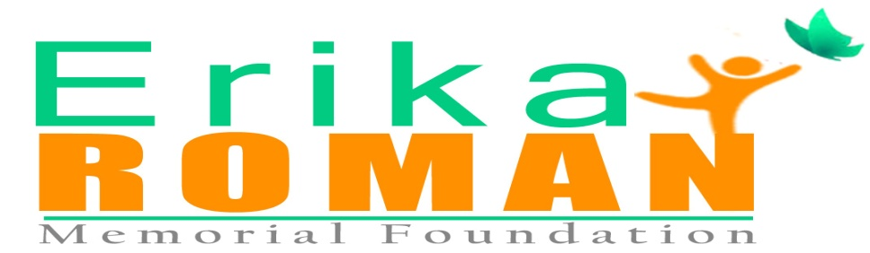

SPONSOR FORM

The Erika Roman Memorial Foundation is pleased to support the following Company sponsorship grant at the level indicated below.

The Erika Roman Memorial 10th Annual Celebrity Softball Fundraiser

Sponsoring company _____________________________________________

Contact name ___________________________________________________

Address ________________________________________________________

Phone _________________________ Fax ___________________________

Email __________________________________________________________

Castle Hill League Field, Bronx NY:
Event is Tuesday August 7, 2018
Rain Date: August 14 , 2018
Please indicate the Sponsorship Level:
[ ] PLATINUM/ $300.00 Banner placement & back page in program  [ ] GOLD/$175.00 Banner placement & full page in program  [ ] SILVER/$100.00 Banner placement or full page in program  [ ] BRONZE/$60.00 ½ page in Program  [ ] BUSINESS CARD AD /$25 in Program | [ ] TABLE/$100.00 ¼ page in Program (sponsor responsible to provide own table)  [ ] TABLE/$150.00 ¼ page in Program & Banner placement  (sponsor responsible to provide own table)  [ ] TABLE/$200.00 ½ page in Program & Banner placement  (sponsor responsible to provide own table)  [ ] FOOD ONLY TABLE/$250.00 ½ page in Program & Set Up by Entrance  Location of table is determined by package purchased  Table sponsor allowed 2 complimentary entries w/pkg

Donate Auction Item(s): _______________________________________________
Team Sponsorship:
$400 which includes: Banner Placement, Full Page Ad & 5 Tee Shirts for Players in Game 5 Players to a Team

Please choose the form of payment:
[ ] Check | [ ] Cash | [ ] Paypal

Checks made to Erika Roman Memorial Foundation
All Net Proceeds will go to The Erika Roman Memorial Foundation
Contact: Sal Abbatiello 914.725.0011 or Darlene Free 646.523.0694

“Living the Dream”
www.erikaromanfoundation.com

