Bethany Dumont
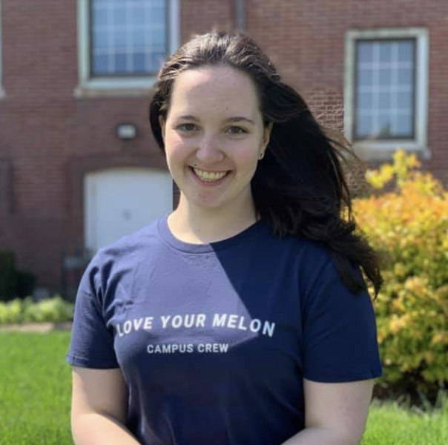
High School: I attended Greater New Bedford Regional Vocational Technical High School while volunteering as an attorney for South Coast Youth Courts. While in high school, I was in the Career/Technical area of Legal and Protective Services.
College: I am now at Bridgewater State University studying Elementary Education and looking forward to being an elementary school teacher.
How did Youth Court prepare you for college: My time volunteering with South Coast Youth Courts gave me a strong foundation in many skills that have helped me far beyond the courtroom. I've gained experience working with children, especially those who may struggle for various reasons in a school environment, and their parents. I've also been able to experience speaking and presenting in front of people through my time in the Youth Court courtroom.
Favorite Memory: Some of my best Youth Court memories are from the relationships I made with other volunteers and members of the community schools and police officers. To this day, I still love the opportunity to share my experiences with South Coast Youth Courts because I truly feel they are able to make a real impact on children who are struggling for one reason or another.

