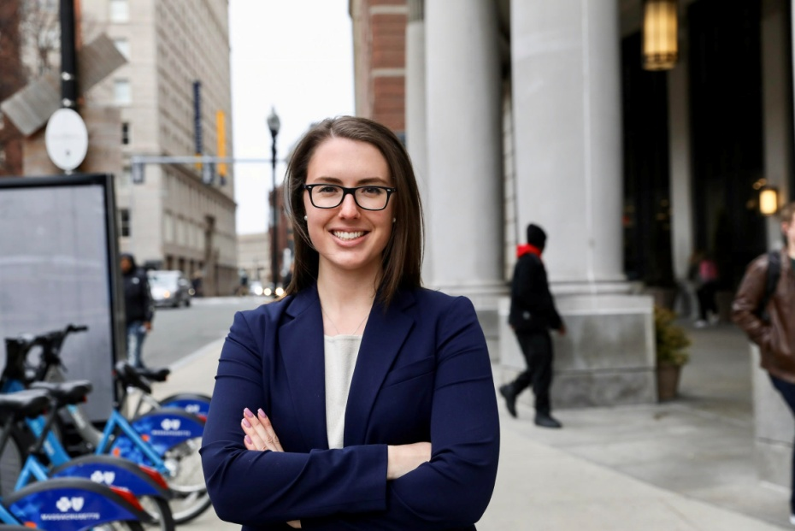
Danielle Paulson
High School: I went to Fairhaven High School and graduated in 2013.
College: I went to Emmanuel College and majored in Sociology with a concentration in Crime and Justice, and a minor in Spanish. I graduated from Emmanuel in 2017.
Law School: I went straight to Suffolk University Law School. I will graduate next May, and I am hoping to pursue a career in criminal appellate work. I have been interning at the Worcester District Attorney’s Office in the Appeals Unit throughout my law school career, and it is exactly the kind of work I want to get involved in.
Skills I learned: Youth Court helped me acquire the skills I now need to advocate in the courtroom. I was able to practice my public speaking at a young age, which still helps me today. Whether it is in my trial advocacy class, or in the courtroom, where I am able to practice using my 3.03 Student Attorney Certification, Youth Court prepped me for what I need to know now. Through the trials, Youth Court also gave me a firsthand look at how a trial is conducted.

Favorite Memory: My favorite memories from Youth Court are all the bonds and relationships I created, that I still cherish to this day. Additionally, I loved that there was an available outlet for me to explore my interest in the legal field at such a young age. I still talk about Youth Court constantly, to my peers, colleagues, and potential employers. It was an invaluable experience that I will always look back on with the fondest memories and gratitude.

