ONE STROKE PAINTING
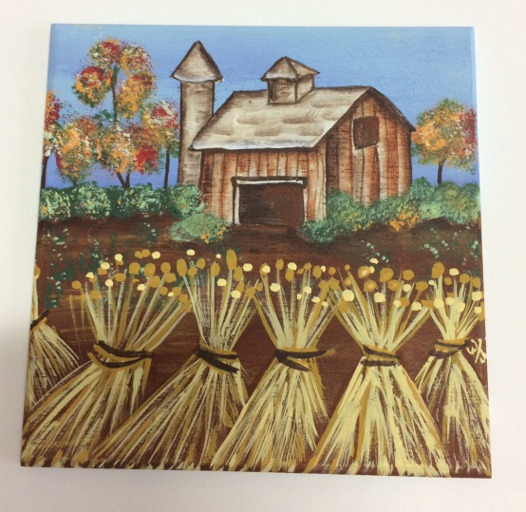
Barn Scene on a Wooden Tile
(3rd in a series of 4)
Wednesday, Feb 21
12:00 pm

Deadline to Register: Monday February 19
LAB Fee:
$15.00 Payable to Instructor
************************
Fees:
55 Plus Member $10.00
Non-Members $15.00

Pre-Registration Required

Call 204-467-2582

