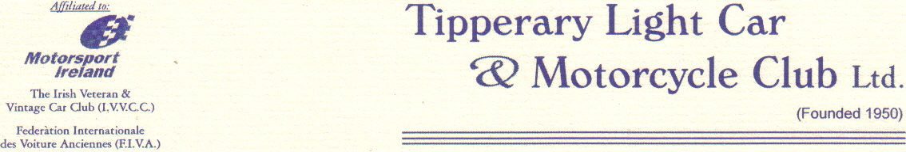

Final Instruction’s 1

- Paper scrutiny will now take place in the Clongibbon House Hotel, the square Mitchelstown between 4.30pm and 9.00pm

- Rally office will be located in the Clongibbon House Hotel on Saturday 12th and will be located in Rally HQ on Sunday 13th

- Parc Ferme and Trailer park has moved to the Mart, this will be sign posted from scrutiny.

- Service area is now located in the mart, ground sheets required.

- Drivers briefing is compulsory for all crews, random car no’s will be called to check attendance. Drivers briefing will now take place on Sunday morning at 8.45am in Parc Ferme

- Due to residents living near Parc Ferme rally cars are not to be started until 10minutes before leaving Parc Ferme.

- C.L.O will be in service.

- The onus is on the competitor to ensure that they have entered the right class.

- Reseeding request will be only taken up until 8pm and will not be taken after this time.

Yours in Motorsport

Tom Dunne
Clerk of the Course

