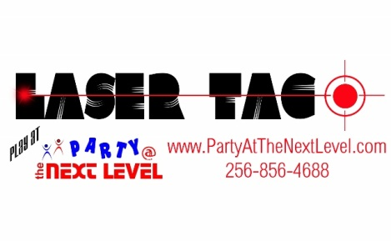
Fill out, sign and mail to:
Michelle Higgins
218 Seymore St
Florence, AL 35630

We

Party Contract
Completion of this contract does not guarantee your party date and time. Reservations through Laser Tag/Party @ Next Level and a deposit are also required.
Deposit paid___________________
Balance paid___________________ cash______ check_____

Party Date:
Party Time:
am/pm to
am/pm

Parent/Guardian’s Name:___________________________ Party child’s name:__________________________

The following must be read and agreed to by the participant of age (18 or older), or the authorized guardian of the
under-age participant (17 or younger).
The Participant agrees with the following rules, terms & conditions:
1 - No projectiles are to be thrown, kicked or otherwise made to be air-born by the participants.
2 - No participant shall engage in any behavior: a-likely to cause injury to themselves, other participants, employees of Laser Tag at Party @ the Next Level, or landowner; b-likely to cause damage to the equipment or property of Laser Tag at Party @ the Next Level, it's employees, or the landowner; c-any other behavior deemed unacceptable by Laser Tag at Party @ the Next Level employees.
3 - Laser Tag at Party @ the Next Level may require any participant engaging in unacceptable behavior to leave the venue.
4 - Each participant must remain inside the battlefield boundaries at all times during play or while holding Laser Tag at Party @ the Next Level equipment.
5 - Each participant will be required to wear clothing and footwear appropriate for the weather and environment, and any gear deemed necessary by Laser Tag at Party @ the Next Level for game play.
6 - Any participant that refuses or is unable to comply with these rules will be unable to participate.
7 - Any participant that is injured, or observes another player injured, shall immediately notify Laser Tag at Party @ the Next Level staff of the incident.
8- All guests & the parent(s) or guardian(s) of all minor children participants are aware of the risks involved in participating in laser tag games & have given their permission for participation in this event.
Release & Discharge:
The participant releases, discharges, waives and forever holds harmless Laser Tag at Party @ the Next Level for all claims for any loss sustained by the participant whether caused by negligent act or willful act or omission, breach of contract, breach of statutory duty or otherwise in connection with Laser Tag at Party @ the Next Level. Participant gives authorization to seek medical attention on their behalf in case of injury.
Warrant As Of Age:
By personally executed this deed, the participant warrants that he or she is at least eighteen (18) years of age. Where this deed is executed by a parent, guardian, or other person for or on behalf of the participant, the person so executing warrants that he or she has the authority to do so and agrees to indemnify Laser Tag at Party @ the Next Level in terms contained in Release and Discharge clause.
Privacy:
Laser Tag at Party @ the Next Level collects information from you for the primary purpose of providing quality entertainment. The information you provide will be used for administrative and billing purposes, emergency situations whereby staff/hospitals require access to a participant's records for appropriate purposes. Laser Tag at Party @ the Next Level will not sell or distribute your information.
Definitions:
In this deed unless inconsistent with the context or subject matter: All Claims means all claims, actions, suits, demands, damages, interest and costs arising out of or as consequence of Laser Tag at Party @ the Next Level including incidental activity. Any Loss means any loss, damage or injury to a person (including the participant) or property including but not limited to any damage or injury caused by falling, tripping, or colliding with objects or other participants on the battlefield, or incidents involving insects or wildlife. Participant means the person whose name appears on this form. Laser Tag at Party @ the Next Level means the division of The Next Level, LLC that provides laser tag for parties and events, and it's agencies, suppliers, employees, agents, representatives, directors, and officers.
_______________________________________________________________________________ Date:____________________________
Signature of parent/guardian (18 or over) or
Name of Guardian authorizing if Participant is under 18 years of age

