Yuman Language Family Summit Immersion Camp June 26-29, 2017. Hosted in Peach​ Springs at Hualapai Youth Camp
All Gathering to Talk the Language
​
​"​Điga:vik, bay ba Gwa:wjik" (Hualapai)
​
"​Matasheevshik kwaarkwaarm" (Piipaash)
​
LAST Yuman Language Family
Summit Steering Committee Mtg.
Monday May 15, 2017 11am-2pm
Hualapai Cultural Center, next to Hualapai lodge in Peach Springs​
​​Meeting Agenda​:
--Camp Schedule draft and revisions​
--Presentation and cultural teachings​
--Registration Form for participants​
--Elderly and limited use camping arrangements​
--Introduction of language use master plan for YLFS 2017​
We are working with Hualapai Lodge and Grand Canyon Caverns to secure rooms people to rent. We will have updates as soon as we can get them posted ​​
​​
For more information and contacts:
Theo De laRosa 928-575-3493
Marcey Craynon 928-769-2223
Gary Owens 480-362-6320 (Mon-Fri. 8-5pm)​​​​

Yuman Language Family Summit Immersion Camp 2017
June 26-29, 2017
Hualapai Youth Camp near peach Springs AZ.

Join us as we all participate in a Yuman Language Use Summit 2017
Participants include language teachers, fluent speakers, language learners:
♦ We will work with models of language for use in a “camp” setting
♦ Try conversations and translation structure
♦ Participate in cultural presentation using language conversation and immersion
♦ Camp out in our own languages.
♦ Work with Yuman fluent speakers and cultural knowledge.
♦ Develop a basic model of creating a language learning environment
♦ Plan Yuman language use in our daily lives.
This is an outdoor camping event. Amenities and use of the Hualapai Youth buildings will be reserved for the elders and those with limited capabilities. Payment for housing and registration is on your own. YFLS committee will over see the camp area and assignment of cabins, tent areas. Some meals will be included in this event. Come and help and make a fire in the language! Information packets will go out May 5th. Registration begins May 8, 2017
For more information please call:
Theo de la Rosa 928-575-3493
Marcey Craynon 928-769-2223
Gary Owens 480-362-6320 Mon-Fri. 8-5pm Registration

​​​ Welcome to a new direction in the revitalization of the Yuman languages. The current Yuman Family Language Summit Committee has decided to take the annual summit outdoors. Following a model of creating a language learning environment, the committee is planning a place where Yuman language can be spoken. For the upcoming year of 2017 the plans are to take our past summit participants and stay at the Hualapai Youth Camp in Peach Spring where we can learn, practice and speak our languages.
​ Our long term goal is to provide a foundation for each tribe to set up their own camps and other events to use the language. We will work will a pre-set list of phrases and words but it will be up to the people to come up with their defined list. The list of phrases to translate into the Yuman language and to bring to the camp is included in this packet but you can add to it and we encourage you to add to it.
​
We had a wonderful site visit on April 24th. The camp site is gorgeous! They are just finishing up the grounds and getting the lodge areas smoothed out. The area feels so good and is less rocky then the wonderful Hualapai Mt. Camp grounds. ​​Some rooms and indoor sleeping quarters are available for the elderly and those with limited capabilities. Tent camp sites are all over the place and we are working on designated camps sites for the Mohave, Quechan, Cocopa, Kumeyaay, Hualapai and more. There are 6 pads available for RV's. We are putting the bids in for a cook to help us with our needs but we are also having the camps cook at their site if they want to. This is open to all those interested in speaking, learning and using our languages. We are also looking to create “lifelines” of language speakers to help people “stay in the language.”
​ We look forward to your participation and we will help you get the lists of things you need to bring, cabins to rent and most important, using your language in a themed setting. Get ready to speak and learn.
Yuman Family Language Summit Committee

YUMAN LANGUAGE FAMILY SUMMIT IMMERSION CAMP 2017
June 26 – 29, 2017 ~ Hualapai Youth Camp
Peach Springs, Arizona
REGISTRATION FORM

The Yuman Language Family Summit Immersion Camp will be in Peach Springs, Arizona. The intent of the Yuman people is to revitalize, maintain and carry on the traditional languages and cultures. We welcome all participates to join us in this task. Early registration deadline is June 14, 2017. Please fill out this registration form and sent it with payment to the address below.

NAME:________________________________________________________
ADDRESS:_____________________________________________________
TRIBAL AFFILIATION:___________________________________________
TELEPHONE:________________E-MAIL:_____________________________

Native Language Speaker Y___ N____ Native Language Teacher Y___ N___
Native Language Learner Y___ N ___ Can Read/Write Language Y___ N___
REGISTRATION FEE IS NON-REFUNDABLE Deadline: Friday, June 14, 2017
PAYABLE TO: Yuman Language Family Summit ~ NO PERSONAL CHECKS/PURCHASE ORDERS
ON-SITE REGISTRATION FEE WILL BE $100.00 FOR ALL AGES

Make Fee payable to: Yuman Language Family Summit

ELDERS- 55 Yrs & over____$60.00 ADULT-18-54 Yrs____$70.00
YOUTH -17 Yrs & under ____$25.00 AGE____ Male___Female ___
MAIL REGISTRATION TO:
FOR MORE INFORMATION & CONTACTS:
Theo De LaRosa (928) 575-3493
Marcy Craynon (928) 769-2223
Gary Owens Jr. (480) 362-6320 M-F 8 to 5
FAX: (480) 362-5728
Huhugam Ki Museum
ATTN: Gary Owens Jr.
10,005 E. Osborn Road
Scottsdale, Arizona 85256
For More Information go to Website:
Yumanlanguagefamilysummit.com
CAMP SCHEDULE DRAFT
Monday
1PM Arrival of people, set up camp areas, check elderly in
5pm Dinner and introductions

Tuesday
Sunrise greetings of the morning according to tribal groups
7am getting up, washing up, etc.
8am Breakfast
9am Camp work—includes cultural presentations, language work, and teaching within the tribal groups without any interruption
Noon Lunch
1:30pm Cultural presentations: People will go from camp to camp to watch and participate in the presentations that were worked on in the morning. This is just a draft plan at this moment.
4pm clean up get ready for bed later that night
5pm Dinner
7pm Storytelling
9pm Campfires out
Wednesday
Sunrise greetings of the morning according to tribal groups
7am getting up, washing up, etc.
8am Breakfast
9am Camp work—includes cultural presentations, language work, and teaching within the tribal groups without any interruption
Noon Lunch
1:30pm Cultural presentations: People will go from camp to camp to watch and participate in the presentations that were worked on in the morning. This is just a draft plan at this moment.
4pm clean up get ready for bed later that night
5pm Dinner
7pm Song and dance, possible teaching of both
9pm Campfires out
Thursday
Sunrise greetings of morning according to tribal groups
7am getting up, washing up, etc.
8am Breakfast
9am Camp evaluations: How did it work, strengths, less than perfect situations, what can we take home and use, etc.
11am Take down camp and sack lunches
Noon Leave for home

LANGUAGE LIST/S
​​​​ We need language for the camp, a starting point. So we have come up with some phrases that you can translate into the Yuman languages. It is not the only list, it is one of many to start with. If you already have a list of phrases, bring them along. We have 101 phrases and although it seemed like a lot it it was barley the beginning. Take a look and if you come up with more please share them with others. I am enclosing this in a word document so you can save it to your computer and add the language without having to write the English all over again. We will add more to the page as we get them.
​Take a look and see what you can translate in your language. You don’t have to fit the Yuman to the English; if you don’t have a phrase for it then that’s okay. Remember this is just a starting point. You may want to go in a different direction. Please be willing to share what you come up with, with your fellow Yumans

Word list DRAFT: what will be spoken? Take a look and see what fits your language. You don’t have to fit the Yuman to the English, if you don’t have a phrase for it then that’s okay. Remember this is just a starting point. You may want to go in a different direction. Please be willing to share what you come up with, with your fellow Yumans
- My friend
- Greeting to a male (exclusively between males)
- Greeting to a female, ( or from a female to others)
- What is your name?
- My name is Paul
- How are you?
- Good / fine
- And how are you? (returning question)
- Are you good?
- Wake up—Wake up (to group)
- It’s morning
- Wash your face
- Brush your hair
- Brush your teeth
- Tooth brush
- Get dressed
- make your bed
- Put your shoes on
- Where are you shoes?
- Are you ready
- Are you ready (more than one-group)
- Hurry
- Hurry lets’ go (to another)
- Hurry let’s go (to a group)
- Take a bath/shower
- It’s a good day
- Get some wood
- Let’s go play (to another person)
- Go play
- Go play (to a group)
- Come in
- How are you (to a group)
- How is your family
- I see you-my heart-good ( I’m glad to see you)
- What are you doing?
- What’s going on?
- Go greet him/her
- Where are you going?
- Where are you going (to a group)
- Are you leaving?
- I’m leaving
- Who is going with you?
- Who are you going with?
- Good bye, I’ll see you again
- When?
- When are you coming?
- When are you leaving
- When are you returning here?
- When will you do it?
- What (looking at, something)
- What is this / that?
- What smells good
- What (object form)
- What are you doing?
- What do you want?
- What do you have?
- Who (subject form)
- Who are you
- Who is that
- Who said it
- Who did it
- Come eat
- Come eat (to a group)
- Let’s eat, shall we eat
- Let eat, shall we eat (to a group)
- Are you hungry
- Are you hungry (to a group)
- Give me a tortilla
- It tastes good
- Are you full
- I am full
- Go ahead and eat
- Sit down and eat
- Set out the dishes
- Clear the table
- Wash the dishes
- Wash your hands
- Let’s pray
- Come here
- Come here ( to a group)
- Sit down
- Sit down (to a group)
- Listen
- Listen (group)
- Behave
- Don’t say that
- I have to go to the bathroom (to sit)
- I’ll be right back
- get to work (to another person)
- Are you sleepy?
- I am sleepy
- I am tired
- Let’s go to sleep
- Are you tired?
- Go to sleep
- I’m going to sleep
- Be quiet
- Be quiet (to a group)
- It’s evening time
- Go lay down
- Good dreams

Camping items and terms: (DRAFT)
- Tent
- Axe
- Firewood
- Fire
- Match/matches
- Pot (metal)
- Pot/clay
- Water
- Spoon
- Fork
- Knife
- Blanket/s
- Mat
- Tarp/covering for ground
- Pine tree
- Ground/earth
- Pillow
- Stake
- Hammer
- Rope
MORE TO COME LATER, WHAT CAN YOU COME UP WITH?

LODGING

This is a camp, we will be camping, setting up tents, making fires, all the things that go with being outdoors. The Hualapai Youth Camp is located north of Peach Springs. It is a camp site with limited indoor bunkhouses which are being held for the elderly. It is a communal use area with the showers and bathrooms being shared by all. There are large areas for tents which will hold the different tribes to camp out together. There are 6 cement pads with hook ups for RV’s. There are limited rooks available off site in Peach Springs and down the road at the Caverns. We encourage the camping out but if you have people in your groups that are elderly or limited then you can work with Marcey Craynon 928-769-2223 in securing a bed in the main Youth Camp lodge or rooms on your own in Peach Springs or at the Caverns. Thank you for your patience.
YLFS Committee​​
MOTELS:
Hualapai Lodge: 928-769-2230. Rooms are being held under Yuman Language Family Summit. You will be paying for these on your own. They are $99.00 plus Tax. The cutoff for the rooms is June23, 2017
8- Rooms available June 26-29th for double occupancy
20- Rooms blocked off for June 26-27.

The Caverns motel is 3 miles west of the Supai turn off.
8 rooms available for the dates June 26-29th. 4 are double beds at $100 and 4 are Kings at $110. Plus there is 10% tax and a $10 charge for any occupants beyond 2 per room. They said if someone calls they may be able to give you cheaper group rate. The number is 928-422-3223 and ask to talk to Jasmine for group deals. Need to call as soon as possible.

TENTS:
If you do not have a tent available we are looking at providing tents for those without. You would still have to put it up on site but if you do not go camping a lot this is a budget alternative. Contact Hualapai Cultural Center for more information 928-769-2223

This is the best map we have so far.

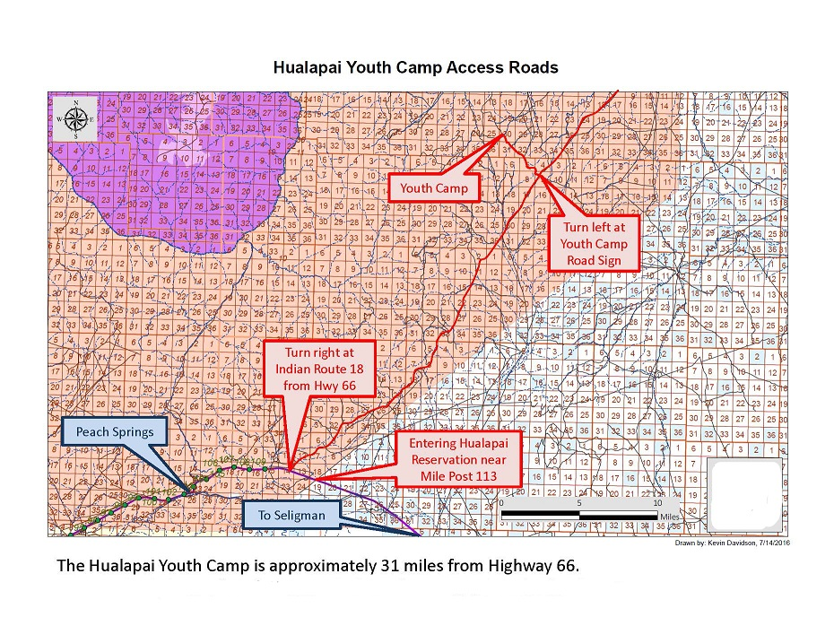

Vendor Form:
Vendor spaces are available but realize that we are in a camp site setting with limited public access. All activities will be taking place at the campsite. It is about 40 minutes to the main highway 66 and then to either Peach Springs or The Caverns. Lodging is limited and on your own. You will have to register for the Summit Camp with payment fitting your age group. This is to insure that you will be able to eat at the camp. We have a space for 6 vendors, first come first available table space. Set up will be on your own and there is no electricity
Use the registration form and WRITE Vendor on the form. We ask that you donate an item for a raffle that will be held on Wednesday night.

Presentations:
We are asking that each camp come up with 2-3 presentations on traditional culture that can be taught in your language. The camp-sites will be set up so that each tribal group will be together, sleep together and maintain their identity in one camp. We are doing this because we want language use and learning to go on in the camps. Morning activities will be in the camps and then in the afternoon sessions we will rotate to the different sites (or meet under the large ramada) and others will learn what was worked on in the morning sessions. What we are looking for is the language to be used by others when the sessions are rotated, when we get together, when we are camping etc.
Some ideas to present:
Cooking Cradleboard making Preparing food for storage
Tool making Gathering wild foods Dance
Songs Stories dressmaking…

Take a look at what it is that you can work on in the language and bring your materials.
For more information Contact Lucille W. at 928-769-2248

