Yuman Language Family Summit Immersion Camp
July 15-18, 2019
Hualapai Youth Camp near peach Springs AZ.

Join us as we all participate in a Yuman Language Use Summit 2019
Participants include language teachers, fluent speakers, and language learners:
♦ We will work with models of language for use in this setting
♦ Try conversations and translation structure
♦ Participate in cultural presentation using language conversation and immersion
♦ Camp out in our own languages.
♦ Work with Yuman fluent speakers and cultural knowledge.
♦ Develop a basic model of creating a language learning environment
♦ Plan Yuman language use in our daily lives.

This is an outdoor camping event. Amenities and use of the Hualapai Youth buildings will be reserved for the elders and those with limited capabilities. Payment for housing and registration is on your own. ALL REGISTRATION PAYMENT NEEDS TO BE MADE OUT TO YUMAN LANGUAGE FAMILY SUMMIT. The YLFS committee will oversee the camp area and assignment of cabins, tent areas. Some meals will be included in this event. Come and help and make a fire in the language! Information packets will go out May 23, 2019. Registration begins May 23, 2019
For more information please call:

Theo de la Rosa 928-575-3493
Marcey Craynon 928-769-2223
Emilio Escalanti 928-920-7805
Gary Owens 480-362-6320 Mon-Fri. 8-5pm
Toni Carlyle: tmcarlyle@hotmail.com

​​​
Welcome to a new direction in the revitalization of the Yuman languages. The current Yuman Family Language Summit Committee has decided to once again hold the annual summit outdoors. Following a model of creating a language learning environment, the committee is planning a place where Yuman language can be spoken. For the upcoming year of 2019, the plans are to take our past summit participants and stay at the Hualapai Youth Camp in Peach Spring where we can learn, practice and speak our languages.
​ Our long term goal is to provide a foundation for each tribe to set up their own camps and other events to use the language. We will provide a pre-set list of phrases and words but it will be up to the people to come up with their defined list. The list of phrases to translate into the Yuman language and to bring to the camp is included in this packet but you can add to it and we encourage you to add to it.
We are working along the same plan that we had in 2017.We will be back at the Youth camp ​​Some rooms and indoor sleeping quarters are available for the elderly and those with limited capabilities. Tent camp sites are all over the place and we are working on designated camps sites for the Mohave, Quechan, Cocopa, Kumeyaay, Hualapai and more. There are 6 pads available for RV's. We are putting the bids in for a cook to help us with our needs. This is open to all those interested in speaking, learning and using our languages. We are also looking to create “lifelines” of language speakers to help people “stay in the language.” In 2017 we found that we had a lot of youth joined us for this camp and we want to make sure that we get youth involved. We would ask that if there will be a group of youth attending from your community that they have the right amount of chaperones for the event.
​ We look forward to your participation and we will help you get the lists of things you need to bring, cabins to rent and most important, using your language in a themed setting. Get ready to speak and learn.
Yuman Family Language Summit Committee

YUMAN LANGUAGE FAMILY SUMMIT IMMERSION CAMP 2019
July 15 – 18, 2019 ~ Hualapai Youth Camp
Peach Springs, Arizona
REGISTRATION FORM

The Yuman Language Family Summit Immersion Camp will be in Peach Springs, Arizona. The intent of the Yuman people is to revitalize, maintain and carry on the traditional languages and cultures. We welcome all participates to join us in this task. Early registration deadline is July 1, 2019. Please fill out this registration form and sent it with payment to the address below.

NAME:________________________________________________________
ADDRESS:_____________________________________________________
TRIBAL AFFILIATION:___________________________________________
TELEPHONE:________________E-MAIL:_____________________________

Native Language Speaker Y___ N____ Native Language Teacher Y___ N___
Native Language Learner Y___ N ___ Can Read/Write Language Y___ N___
$75.00 REGISTRATION FEE IS NON-REFUNDABLE
Deadline: MONDAY, JULY 1, 2019
PAYABLE TO: Yuman Language Family Summit ~ NO PERSONAL CHECKS/PURCHASE ORDERS
ON-SITE REGISTRATION FEE WILL BE $100.00 FOR ALL AGES

REGISTRATION FEE: $75.00
ALL REGISTRATION FEES ARE PAYABLE TO: YUMAN LANGUAGE FAMILY SUMMIT

Mail Registrations and payment to:
CONTACT NUMBERS
Emilio Escalanti: (928) 920.7805
Theo DeLaRosa: (928) 575.3493
Marcy Craynon: (928) 279.3787

Yuman Summit- P.O. box 787, Parker, Az 85344

Or FAX: 480-362-5726

E-MAIL to: tmcarlyle@hotmail.com
For More Information go to Website:
Yumanlanguagefamilysummit.com

CAMP SCHEDULE DRAFT Each Camp will be responsible for 3 hour sessions. You will give out directions as to how each morning, afternoon, and evening session will be conducted.

Monday Note: There are no activities planned except for setting up the camps.

1PM Arrival of people, set up camp areas, check elderly in
5pm Dinner and introductions
The Yuman Language Family Summit Steering will be in Charge.

Tuesday
Sunrise greetings of the morning according to tribal groups
7am getting up, washing up, etc.
8am Breakfast
9am HUALAPAI TRIBE WILL BE IN CHARGE
Camp work—includes cultural presentations, language work, and teaching within the tribal groups without any interruption
Noon Lunch
1:30pm _________TRIBE WILL BE IN CHARGE
Cultural presentations: People will go from camp to camp to watch and participate in the presentations that were worked on in the morning. This is just a draft plan at this moment.
4pm clean up get ready for bed later that night
5pm Dinner
7pm _________TRIBE WILL BE IN CHARGE
Storytelling
9pm Campfires out
Wednesday
Sunrise greetings of the morning according to tribal groups
7am getting up, washing up, etc.
8am Breakfast
9am _________TRIBE WILL BE IN CHARGE
Camp work—includes cultural presentations, language work, and teaching within the tribal groups without any interruption
Noon Lunch
1:30pm _________TRIBE WILL BE IN CHARGE
Cultural presentations: People will go from camp to camp to watch and participate in the presentations that were worked on in the morning. This is just a draft plan at this moment.
4pm clean up get ready for bed later that night
5pm Dinner
7pm _________TRIBE WILL BE IN CHARGE
Song and dance, possible teaching of both
9pm Campfires out

Thursday
Sunrise greetings of morning according to tribal groups
7am getting up, washing up, etc.
8am Breakfast
9am The Yuman Language Family Summit Steering will be in Charge.

Camp evaluations: How did it work, strengths, less than perfect situations, what can we take home and use, etc.
11am Take down camp and sack lunches
Noon Leave for home

LANGUAGE LIST/S
​​​​ We need language for the camp, a starting point. So we have come up with some phrases that you can translate into the Yuman languages. It is not the only list, it is one of many to start with. If you already have a list of phrases, bring them along. We have 101 phrases and although it seemed like a lot it it was barley the beginning. Take a look and if you come up with more please share them with others. I am enclosing this in a word document so you can save it to your computer and add the language without having to write the English all over again. We will add more to the page as we get them.
​Take a look and see what you can translate in your language. You don’t have to fit the Yuman to the English; if you don’t have a phrase for it then that’s okay. Remember this is just a starting point. You may want to go in a different direction. Please be willing to share what you come up with, with your fellow Yumans

Word list DRAFT: what will be spoken? Take a look and see what fits your language. You don’t have to fit the Yuman to the English, if you don’t have a phrase for it then that’s okay. Remember this is just a starting point. You may want to go in a different direction. Please be willing to share what you come up with, with your fellow Yumans

- My friend
- Greeting to a male (exclusively between males)
- Greeting to a female, ( or from a female to others)
- What is your name?
- My name is Paul
- How are you?
- Good / fine
- And how are you? (returning question)
- Are you good?
- Wake up—Wake up (to group)
- It’s morning
- Wash your face
- Brush your hair
- Brush your teeth
- Tooth brush
- Get dressed
- make your bed
- Put your shoes on
- Where are you shoes?
- Are you ready
- Are you ready (more than one-group)
- Hurry
- Hurry lets’ go (to another)
- Hurry let’s go (to a group)
- Take a bath/shower
- It’s a good day
- Get some wood
- Let’s go play (to another person)
- Go play
- Go play (to a group)
- Come in
- How are you (to a group)
- How is your family
- I see you-my heart-good ( I’m glad to see you)
- What are you doing?
- What’s going on?
- Go greet him/her
- Where are you going?
- Where are you going (to a group)
- Are you leaving?
- I’m leaving
- Who is going with you?
- Who are you going with?
- Good bye, I’ll see you again
- When?
- When are you coming?
- When are you leaving
- When are you returning here?
- When will you do it?
- What (looking at, something)
- What is this / that?
- What smells good
- What (object form)
- What are you doing?
- What do you want?
- What do you have?
- Who (subject form)
- Who are you
- Who is that
- Who said it
- Who did it
- Come eat
- Come eat (to a group)
- Let’s eat, shall we eat
- Let eat, shall we eat (to a group)
- Are you hungry
- Are you hungry (to a group)
- Give me a tortilla
- It tastes good
- Are you full
- I am full
- Go ahead and eat
- Sit down and eat
- Set out the dishes
- Clear the table
- Wash the dishes
- Wash your hands
- Let’s pray
- Come here
- Come here ( to a group)
- Sit down
- Sit down (to a group)
- Listen
- Listen (group)
- Behave
- Don’t say that
- I have to go to the bathroom (to sit)
- I’ll be right back
- get to work (to another person)
- Are you sleepy?
- I am sleepy
- I am tired
- Let’s go to sleep
- Are you tired?
- Go to sleep
- I’m going to sleep
- Be quiet
- Be quiet (to a group)
- It’s evening time
- Go lay down
- Good dreams
Camping items and terms: (DRAFT)
- Tent
- Axe
- Firewood
- Fire
- Match/matches
- Pot (metal)
- Pot/clay
- Water
- Spoon
- Fork
- Knife
- Blanket/s
- Mat
- Tarp/covering for ground
- Pine tree
- Ground/earth
- Pillow
- Stake
- Hammer
- Rope

CAMPING

This is a camp, we will be camping, setting up tents, making fires, all the things that go with being outdoors. The Hualapai Youth Camp is located north of Peach Springs. It is a camp site with limited indoor bunkhouses which are being held for the elderly. It is a communal use area with the showers and bathrooms being shared by all. There are large areas for tents which will hold the different tribes to camp out together. There are 6 cement pads with hook ups for RV’s. There are limited rooks available off site in Peach Springs and down the road at the Caverns. We encourage the camping out but if you have people in your groups that are elderly or limited then you can work with Marcey Craynon 928-769-2223 in securing a bed in the main Youth Camp lodge or rooms on your own in Peach Springs or at the Caverns. Thank you for your patience.
NOTE: ALL PERSONS ARE TO REGISTER IF YOU ARE AT THE YOUTH CAMP AREA.
YLFS Committee​​

TENTS:
If you do not have a tent available we are looking at providing tents for those without. You would still have to put it up on site but if you do not go camping a lot this is a budget alternative. Contact Hualapai Cultural Center for more information 928-769-2223.

Presentations:
Each Camp will be responsible for 3 hour sessions. You will give out directions as to how, each morning, afternoon, and evening session will be conducted.

We are asking that each camp come up with 2-3 presentations on traditional culture that can be taught in your language. The camp-sites will be set up so that each tribal group will be together, sleep together and maintain their identity in one camp. We are doing this because we want language use and learning to go on in the camps. Morning activities will be in the camps and then in the afternoon sessions we will rotate to the different sites (or meet under the large mathkyaaly/ramada) and others will learn what was worked on in the morning sessions. What we are looking for is the language to be used by others when the sessions are rotated, when we get together, when we are camping etc.
Some ideas to present:
Cooking Cradleboard making Preparing food for storage
Tool making Gathering wild foods Dance
Songs Stories dressmaking…
Take a look at what it is that you can work on in the language and bring your materials. For more information Contact Lucille Watahomigie at 928-769-2234

This is the best map we have so far.

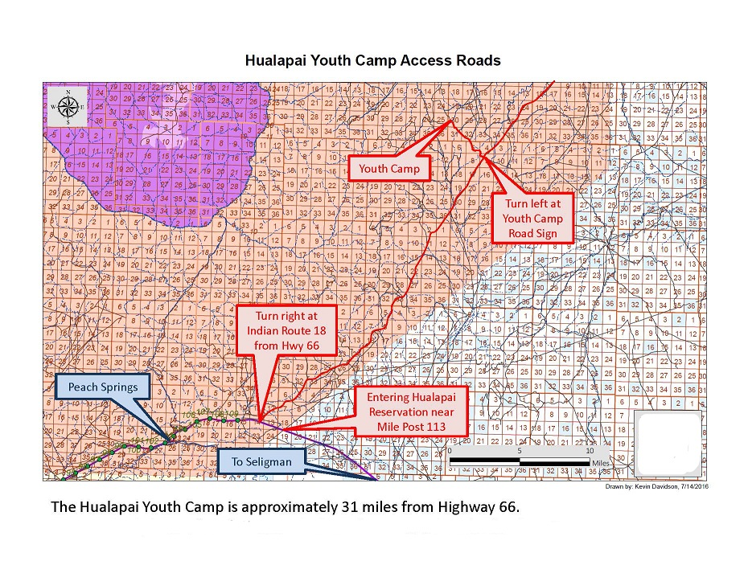

Yuman Language Family Summit Immersion Camp
July 15-18, 2019.
Peach‌ Springs at Hualapai Youth Camp
Dear Relatives,
The 16th Yuman Language Family Summit Immersion Camp 2018 will be on July 15 – 18, 2017 at the Hualapai Youth Camp outside of Peach Springs, Arizona.
We will be honoring language activists who are dedicated to the preservation and revitalization of Yuman Languages. These are individuals who continue to speak their Yuman languages and are passing it on to the non-speakers by teaching, mentoring, making recordings, songs, storytelling, and speaking their native language whenever possible. We are requesting that you nominate 2-4 individuals from your community who are very involved and contribute to keeping the language alive.
Please submit a short biography of the successful language maintenance and preservation activities that the individual is involved in. The individual does not need to be present to be honored but we encourage it. The deadline for the nominations is July 8, 2019 so we can plan. Please turn in the names and addresses of the individuals to me. Each tribe is responsible to bring tribal gifts for 4 elders each. Thank you very much for your cooperation.
Sincerely,

Gertrude Smith
Yavapai-Apache Nation
Yavapai-Culture Dir.
928-649-6963 (Office)

Name-tribe:
Address: Box#/Street , City, State, Zipcode

Email/Telephone
Sort Biography of the successful language maintenance and preservation activities (use another paper if needed)
Name of person Nominating, tribe , organization, nation
Address: Box#/Street , City, State, Zipcode

Email/Telephone

