The Senior Gazette
December 2018
Dallastown Nursing Center
623 E. Main St.
Dallastown, PA 17313
(717) 244-2295
Website:
www.dallastownnursingcenter.com
You can email your loved one anytime at the following email address:
dbixler@dallastownnursingcenter.com
Christmas Bazaar Update
Our Christmas Bazaar, was held in conjunction with the “Christmas in Dallastown”, on Saturday, November 3rd. It was a day full of fun, crafts and food! We earned money for the Activity Fund- a fund the residents use for special trips/events. A portion of the money is also used towards donations to Animal Rescue Shelters and The Alzheimer’s Walk.
A big thank-you, to all the resident, their families, staff and volunteers, for all your hard work and dedication!
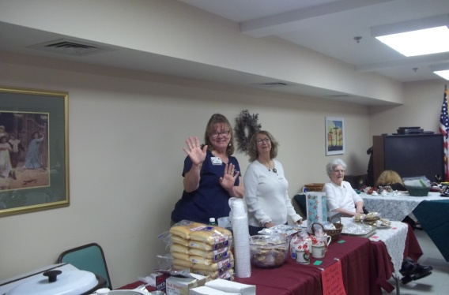
Donna and Kathy-“manning” the bake-sale table.

Christmas party and Gift Giving
Our Christmas Party is scheduled for Thursday, December 20th at 2:30pm. The “Secret Santa” gifts will be distributed, by none other than Santa himself! Evelyn will play the piano while we sing Christmas Carols! Refreshments will be served afterwards.
p.s.- If you took a name from the “Secret Santa” wreath, please make sure to give it to the Activity Department by Friday, December 14th.
“Tall in the Saddle” will be performing at our New Year’s Eve Party, scheduled for Monday, December 31st at 2:00pm. We will celebrate in the Villa Activity Room.
December Birthdays
We will celebrate our December birthdays on Tuesday, December 11th. Dominic Cico will be our entertainer!
Pat S.-12/8
__________________________
“Mitten” and “Santa Paws” Tree
There will be a “Mitten Tree” in the Sun Room this year. We will also have “Santa Paws” included on the tree. Participants are to trake a mitten or a paw form the tree and purchase the item indicated on the mitten/paw. Put the purchased item in the box provided. The Activity Staff will ensure the delivery of the gifts to the Animal Rescue and The Salvation Army.

“Shop-ility”
“Shop-ility” is a traveling store,that visits the Villa every other Friday. Residents from both the DNC and the Villa can purchase general supplies such as snacks, gifts and stationary items.
Cash and “Shop-ility” coupons are accepted. The coupons are available to win at bingo games.
Check the DNC Activity Calendar for dates and times.
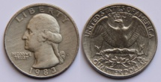

All Around the DNC
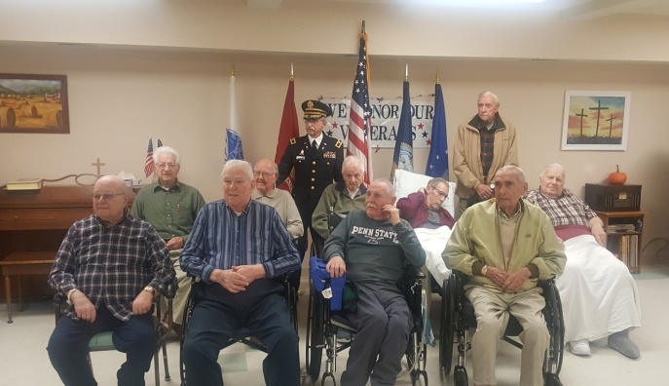
Veteran’s Day Service
November 10th, 2018
Our Heros!

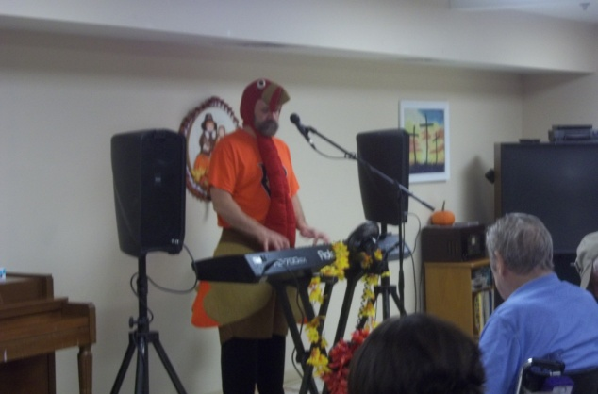
Jimmy Edwards
November 20th, 2018
Jimmy was dressed as a turkey! We always have a good laugh, when Jimmy visits us! Also, a great sing-a-long!

______________________________________

Please feel free to direct any questions or concerns to the appropriate department:
Sue Boone– Administrator
Tammie Johnson – Director of Nursing
Stacie Achenbach –Food Service Director
April Snyder – Environmental Services
Diana Bixler - Activity Director
Woody Harrison-Maintenance
Steph Freed, LPN-Soc. Serv./IC/Staff Dev.

AIR

