The Victorian Times
December 2018

Victorian Villa Personal Care Home
621 E. Main St.
Dallastown, PA 17313
(717) 244-9722
Website:
www.dallastownnursingcenter.com
You can email your loved one anytime at the following email address:
dbixler@dallastownnursingcenter.com
Christmas Bazaar Update
Our Christmas Bazaar was held, in conjunction with “Christmas in Dallastown”, on Saturday, November 3rd. It was a day full of fun, crafts and food! We earned money for the Activity Fund- a fund the residents use for special trips/activities. We also use a portion of the money towards donations to The Alzheimer Walk and Animal Rescue Shelters.
A big Thank You, to all the residents, their families, staff and volunteers, for all your hard work and dedication!
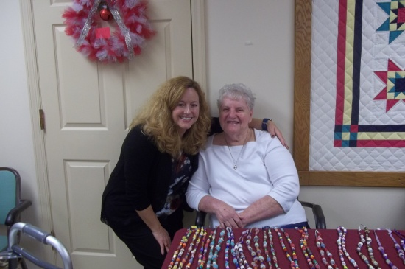
Jeanne and Michelle
Christmas Party and Gift Giving
Our Christmas Party is scheduled for Thursday, December 20th at 1:45pm. The “Secret Santa” gifts will be distributed, by none other than Santa himself ! Evelyn will provide piano music for us to sing Christmas Carols to and we will enjoy festive refreshments afterward!
P.S.- If you took a name from the “Secret Santa” wreath, please make sure to give it to the Activity Department by Friday, December 14th.

December Birthdays
Lois M-12/12
Libby S.-12/22
Ronald L.-12/24
Ruth B.-12/28
We will be celebrating our birthdays on Tuesday, december 11th at 2:00pm. Dave Jacoby will be our performer.
____________________
“Tall in the Saddle” will be performing for us, during our New Year’s Eve Celebration on Monday, December 31st at 2:00pm.

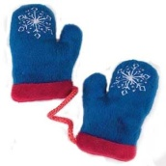
Mitten and Santa Paws Tree
There will be a “Mitten Tree” in the Villa Lobby this year. We will also have “Santa Paws”, included on the tree.
Participants are to take a mitten or a paw from the tree and purchase the item indicated on the mitten/paw. Put the purchased items in the box provided. The Activity Staff will ensure the delivery of the gifts to the Animal Rescue Shelter or The Salvation Army.
Around the villa
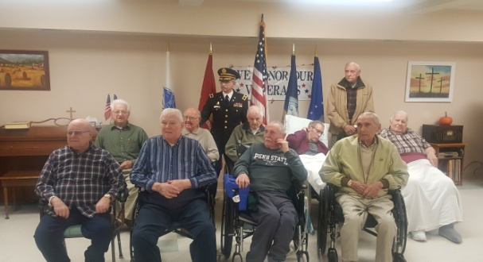
Veteran’s Day Service
November 10th, 2018
Chaplain Kissinger (who is also a Hero!) standing with our “Heroes”!
Please feel free to direct any questions or concerns to the appropriate department:

Sue Boone– Administrator
Tiffany Kauffman – Personal Care Administrator
Linda Jermyn-Director of Wellness
Stacie Achenbach-Food Service Director
April Snyder – Environmental Services
Diana Bixler-Activity Director
Woody Harrison-Maintenance
Steph Freed-Soc. Serv./IC/Staff Dev.

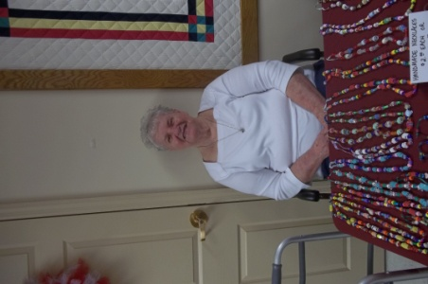
Christmas Bazzar
November 3rd, 2018
Jeanne Strouse with her beautiful necklaces she crafted for the Christmas Bazaar! Jeanne and her daughter also made ornaments, “Reindeer Food” and baked breads for the bake sale. Thank you to Jeanne and her daughter for all the items they made for the sale!

