The Victorian Times
OCTOBER 2018

Victorian Villa Personal Care Home
621 E. Main St.
Dallastown, PA 17313
(717) 244-9722
Website:
www.dallastownnursingcenter.com
You can email your loved one anytime at the following email address:
dbixler@dallastownnursingcenter.com
“Autumn Tapestry”
With just a whisper of wintry chill,
And a sprinkling of frost-diamonds over the hill,
A blazing new sun in the blue sky above,
Autumn has come to the mountains I love.
The mountains are vistas of beauty untold;
Warm shades of burgundy, red, green, and gold.
Leaves of all colors come scurrying by,
Racing the clouds that scamper on high.
The white of a church spire, meadows of brown,
Hills misty purple, with clouds for a crown;
God shows us beauty in so many ways,
Each golden moment of bright autumn days.

-Ruth G. Newman

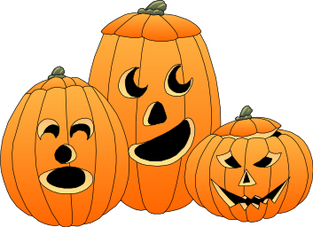

Halloween Party

On October 31st, Mary-Kate (the harpist), will be joining us for our Halloween celebration! Dress up in a costume and join us, for lots of “spooky” fun and food! (costume not required, but is a fun way to show up at a party).
Time: 2:00pm
Place: Villa Activity Room
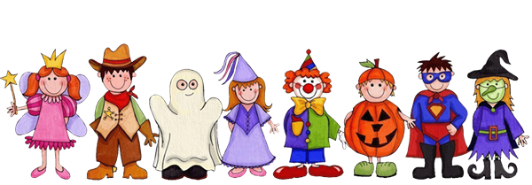
Also, Halloween night, from 6;00-7:00pm, we will be handing out goodies to the Trick or Treaters! Activity staff will provide candy for residents to give to the children.

“Walk to End Alzheimer’s”
Saturday, October 20th at 10:00am, staff from the Victorian Villa and the DNC will be walking at John C. Rudy Park in York. We encourage EVERYONE to “join the fight”! Please see staff for additional information regarding the walk and how you can help us work towards a cure!

OCTOBER BIRTHDAYS
Residents:
10/21-Peck F.
10/11-Marvin J.
10/29-Lorraine P.
Celebrate our October birthdays on October 9th at 2:00pm. Our entertainer will be Sterling Lamm!
____________________
Art Therapy with Megan
October 16th, Megan will be here to assist us with creating beautiful autumn works of art! Arrive between the hours of 1:30-3:00pm, in the activity room.
Christmas bazaar
November 3rd, 9:00am-3:00pm, we will be hosting a Christmas Bazaar in the Villa Activity Room. We will be accepting baked goods, gently used jewelry and Christmas items and crafts. 2 sizes of tables will be available to rent, as well. See the activity staff for more information.

Around the villa
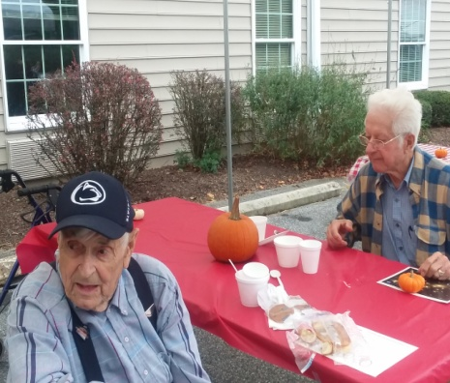
While George is eyeing the pumpkin, Charles is watching the entertainers!
Fall Fest Fun! 9/22/2018
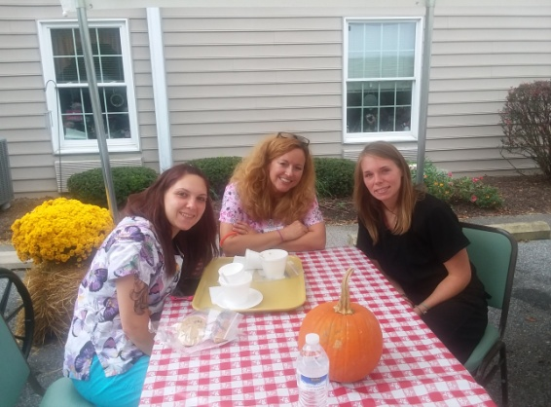
The weather cooperated, this year, and we were able to hold our annual “Fall Fest” outside! Good times and food were had by all! See the accompanying flyer for more pictures! Thank you to all the staff, volunteers, family and residents, who helped make the Fest such a success!
Please feel free to direct any questions or concerns to the appropriate department:

Sue Boone– Administrator
Tiffany Kauffman – Personal Care Administrator
Linda Jermyn-Director of Wellness
Stacie Achenbach-Food Service Director
April Snyder – Environmental Services
Diana Bixler-Activity Director
Woody Harrison-Maintenance
Steph Freed-Soc. Serv./IC/Staff Dev.

