The Senior Gazette
August 2018
Dallastown Nursing Center
623 E. Main St.
Dallastown, PA 17313
(717) 244-2295
Website:
www.dallastownnursingcenter.com
You can email your loved one anytime at the following email address:
dbixler@dallastownnursingcenter.com

Still Summer
The end of summer is near.
We so enjoy our cold rootbeer.
We still take dips in the pool,
And kids are getting ready for school.
Flowers are vibrant and bright,
Watermelons and apples,
Still our delight.
Deep green remains
The color, of the grass.
Geez, the summer is passing so fast!
The Labor Day Parade
Is around the corner.
And the kids will be in for a treat;
Because marching
Laborers and firemen,
Love to throw out all kinds of sweets.
Parks are still filled with
Picnics and kids,
And people enjoying a good game
Of baseball.
We still drink deeply of summer,
Until we come to fall.

-The DNC Poets Archive
Dog Days of Summer!
We still have a lot more summer left, and we have plenty of activities scheduled for you to take advantage of! One summer-themed activity we will have is a “Beach Party”, with Sandy Heisey. It is scheduled for August 9th at 2:00pm, in The Villa.
August 16th, we will be husking corn,
for lunch.
On August 21st, at 2:00pm, we will see a special presentation, “Night Wonders of Astronomy”-presented by Ronald Bolton.
Please see the Activity Staff, if you have any questions regarding the scheduled activities.
August 31st- 8:00am-2:00pm
The Villa and DNC are teaming up for another sale! All proceeds benefit the Alzheimer’s Walk.

Please feel free to direct any questions or concerns to the appropriate department:
Sue Boone– Administrator
Deb Mayer – Director of Nursing
Linda Jermyn – Social Services
Stacie Achenbach –Food Service Director
April Snyder – Environmental Services
Diana Bixler - Activity Director
Woody Harrison-Maintenance
Steph Freed-LPN, Infection Control

August Birthdays
We will celebrate our August birthdays on Tuesday, August 14th . Kirk Folk will be our entertainer!

Bruce N.-8/4

Bingo Coupon Exchange
The Activity Staff will now be offering opportunities for bingo winners, who choose the coupon-option, to use their coupons as cash, at the “Shop-ility” mobile store service. “Shop-ility” is a new service, visiting local facilities, like us- giving residents opportunities to shop, without leaving the home.
The “Shop-ility” mobile store will be visiting 2-3 times per month. They will be stationed in the Villa Activity Room. Staff will be available to transport residents to the Villa and offer assistance with shopping.
Check the Activity Calendar for scheduled dates.

All Around The DNC
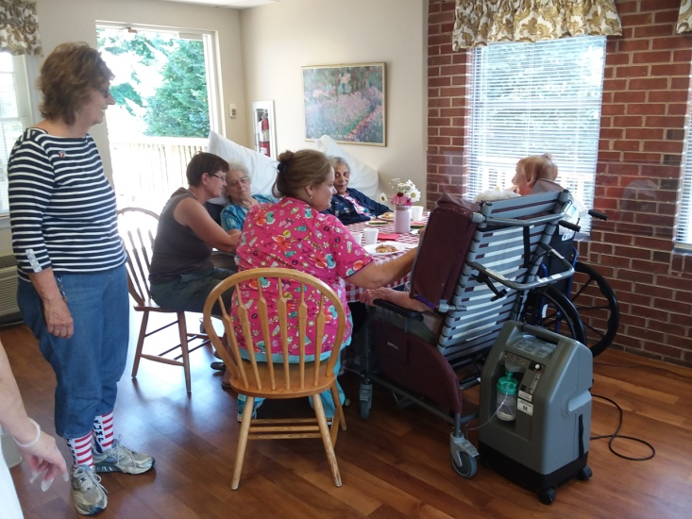
Summer Picnic 2018
Janelle, a member of the Activity Department , is seen here offering assistance, to the indoor participants, during our picnic. It was held on June 29th.
“Magical Melodies”
Bob Bracilano will present “Down Memory Lane”, a fun and interactive musical knowledge game. Please join us on Tuesday, August 28th at 2:00pm, in the Villa Activity Room.

AIR

