The VictorianTimes
August 2018

Victorian Villa Personal Care Home
621 E. Main St.
Dallastown, PA 17313
(717) 244-9722
Website:
www.dallastownnursingcenter.com
You can email your loved one anytime at the following email address:
dbixler@dallastownnursingcenter.com

Vacations
The vacation memories,
That we hold dear,
Are the times spent with loved ones,
Both far and near;
Whether lying in the sunny sand,
Or listening to the hometown band.
All was a treat for anyone around.
(Some went to Israel and walked on
Holy Ground!)
In paris some watch the beautiful
Follies perform,
(And we wonder if the latrines have
Been reformed?)
But it does’nt matter where you roam;
We all agree-
There’s no place like
Home!
-The Villa Poets Archive
August Greetings!
We, at the Villa, hope you are enjoying your summer as much as we are! Our August calendar is busting out all over, with many summer-style activities! Scenic Drives, a beach-themed party, entertainers, shopping trips, and special presentations, are just a few of the activities that are offered this month. We will be having another Yard Sale on 8/31! There is something for everyone-so come on out and join us as we celebrate the last month of summer!
Corn Husking
We will be husking corn on Thursday, August 16th at 10:00am. The corn will then be cooked by dietary and served during lunch, with tomato sandwiches.
August Birthdays
Celebrate our August birthdays on Tuesday, August 14th at 2:00pm! Tom Shelley will be our entertainers. Cake and ice cream will be served!
Residents:
Velma S.-8/21
Staff:
Tiffany K.-8/17
Carol T.-8/17

“Shop-ility” Coupon Exchange
We are switching-up how we exchange our bingo coupons! During bingo, evryone has the opportunity to pick coupons, rather than snacks. Those coupons will now be worth .50 cents towards items for sale at the “Shop-ility” mobile store. See the Activity Staff for further details, and check the activity calendar for “Shop-ility” dates.
Villa Photo-Album
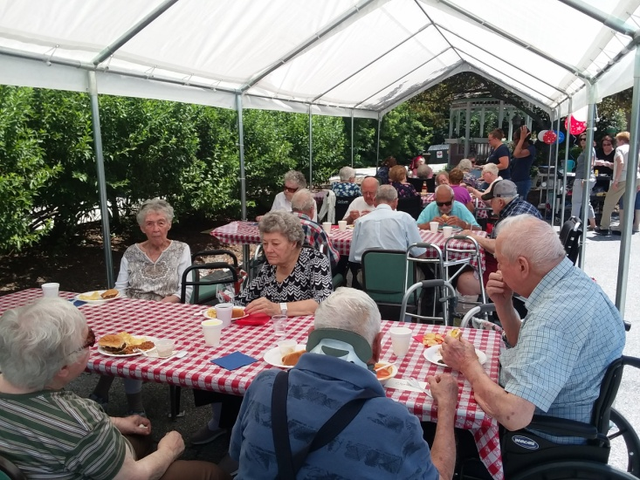
Summer Picnic 2108
June 29th
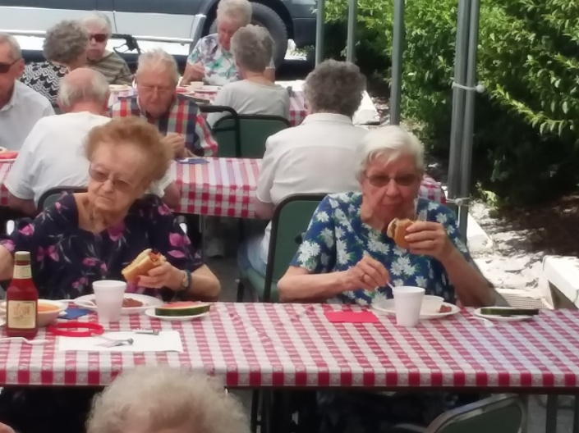
Pat and Ruth enjoying some tasty burgers!

Please feel free to direct any questions or
concerns to the appropriate department:

Sue Boone – Administrator
Tiffany Kaufman– Personal Care Administrator
Linda Jermyn – Social Services
Stacie Achenbach – Food Service Director
April Snyder – Environmental Services
Diana Bixler – Activity Director
Woody Harrison-Maintenance
Steph Freed-LPN-Infection Control

Please feel free to direct any questions or concerns to the appropriate department:

Sue Boone – Administrator
Jennifer Warfel – Personal Care
Administrator
Linda Jermyn – Social Services
Stacie Achenbach – Food Service
Director
April Snyder – Environmental Services
Diana Bixler – Activity Director

