The Senior Gazette
May 2018
Dallastown Nursing Center
623 E. Main St.
Dallastown, PA 17313
(717) 244-2295
Website:
www.dallastownnursingcenter.com
You can email your loved one anytime at the following email address:
dbixler@dallastownnursingcenter.com

“National Nursing Home Week”
May 13th-19th, 2018
We will be celebrating “National Nursing Home Week” with special activities throughout the week! All residents and staff are encouraged to participate in the activites and special daily themes! Look for signs with details about this special event. Also, check the activity calendar for scheduled activities and daily themes.
See Steph Freed or April Snyder, if you have any questions.

We will be pampered for Mother’s Day this year, by having a special “Mother’s Day Spa”! It will be held on Wednesday, May 9th, from 1:30-3:30pm. We will join the Victorian Villa, in the Activity Room, for massages, manicures, simplified-facials and light refreshments. “Relaxing Note” , from Red Lion, will be providing our massages. We will have a sign-up sheet for any residents who are interested in participating. See activity staff for details.

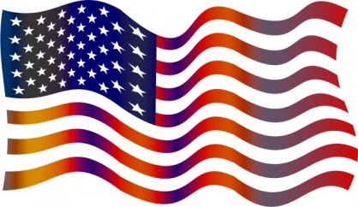
Memorial Day
Monday, May 28th
A day to remember and honor all the brave heroes who served, to hold our flag high.

May Birthdays
We will celebrate our May birthdays on Tuesday, May 8th. Tom Shelley will be our entertainer!
Harold F. 5/3
Joann D. 5/13
Carson D. 5/25

“I Remember Mother”
She:
Was wonderful.
Sewed my clothes.
Took good care of me.
Baked bread every week.
Explained things to me.
Made a 30lb. turkey, with all the trimmings, every Thanksgiving.
Took me to church.
Made cookies, when I came home from school.
Liked the Baltimore Orioles.
Was always working.
Had lots of fun with me.
Was always kind.
Worked around the house and did things for granddaddy.
Licked me when I was bad!
-The Dnc Poets Archives
All Around the DNC
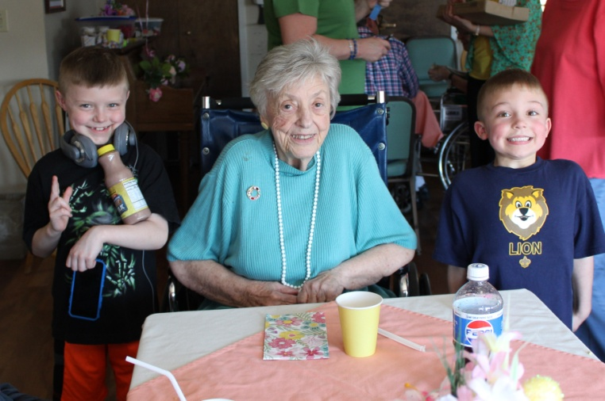
(Lois K. and her grandsons)
On April 14th, the DNC held it’s 2nd annual “Spring Fling”! Residents and their families had a great time!
A luncheon was provided by dietary, followed by bingo and door prize drawings!
Wedding Anniversary:
AIR
Please feel free to direct any questions or concerns to the appropriate department:
Sue Boone– Administrator
Deb Mayer – Director of Nursing
Linda Jermyn – Social Services
Stacie Achenbach –Food Service Director
April Snyder – Environmental Services
Diana Bixler - Activity Director
Woody Harrison-Maintenance
Steph Freed-LPN, Infection Control

Carson and Joann D.
May 27th
63 years of wedded bliss!

