The VictorianTimes
May 2018

Victorian Villa Personal Care Home
621 E. Main St.
Dallastown, PA 17313
(717) 244-9722
Website:
www.dallastownnursingcenter.com
You can email your loved one anytime at the following email address:
dbixler@dallastownnursingcenter.com

“National Nursing Home Week”
May 13th-19th 2018

The Victorian Villa and the DNC will be celebrating the week, with special events and daily themes! Residents, staff and family members are invited to participate in the week-long festivities!
Look for signs with details about the daily themes and special activities/games. Also, check the activity calendar for scheduled activities.

See Steph Freed or April Snyder, if you have any questions.

We will be pampered for Mother’s Day this year, by having a special “Mother’s Day Spa”, on Wednesday, May 9th, from 1:30-3:30pm. There will be manicures, simplified-facials, massages and light refreshments offered. “Relaxing Note”, from Red Lion will provide the massages. We will have a sign-up sheet to accomadate all those wishing to participate. Please see activity staff for further information.
Memorial Day
Monday, May 28th
A day to remember and honor all the heroes who served, to hold our flag high.

May Birthdays
Celebrate our May birthdays on Tuesday, May 8th at 2:00pm! Pam and Don Geiselman will be our entertainers. Cake and ice cream will be served!
_________________
“Mother”

Mother is a name I cherish,
Remembering her, from days gone by;
Always watching over her family.
Her ways of love, faith and disipline;
Will always be remembered.
Cooking, baking, cleaning and gardening
Are the events that filled her day.
Please feel free to direct any questions or
concerns to the appropriate department:

Sue Boone – Administrator
Tiffany Kaufman– Personal Care Administrator
Linda Jermyn – Social Services
Stacie Achenbach – Food Service Director
April Snyder – Environmental Services
Diana Bixler – Activity Director
Woody Harrison-Maintenance
Steph Freed-LPN-Infection Control

Her faith in God showed through,
In the life she lived.
Generous to all that came by to visit;
Offering homemeade bread, soup, cakes and pies.
Nothing was too much work for my mother!
-The Villa Poets archives
VILLA HAPPENINGS
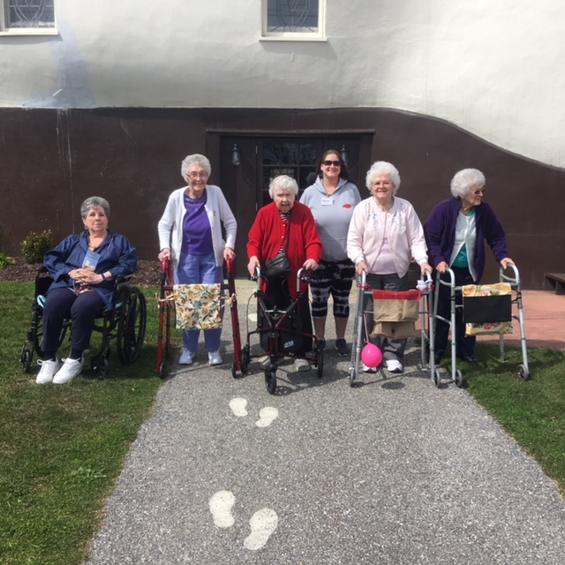
Left to right: Theda, Libby, Lorraine, Dawn, Treva and Mabel.
On April 12th, we paid a visit to “The Haines Shoehouse” in York. We had the “whole shoe” to ourselves! The current owner, Melanie Schmuck, accommodated us on a day they usually are not open! We had a wonderful time hearing the history of the shoehouse ,reminiscing and eating ice cream!
Victorian Villa residents will be attending a York “Revolution” baseball game on May 30th. See Activity staff if you would like to sign up for the trip.

Please feel free to direct any questions or concerns to the appropriate department:

Sue Boone – Administrator
Jennifer Warfel – Personal Care
Administrator
Linda Jermyn – Social Services
Stacie Achenbach – Food Service
Director
April Snyder – Environmental Services
Diana Bixler – Activity Director

