The Victorian Times

**March 2018**

Victorian Villa Personal Care Home

621 E. Main St.

Dallastown, PA 17313

(717) 244-9722

Website:

www.dallastownnursingcenter.com

You can email your loved one anytime at the following email address:

[dbixler@dallastownnursingcenter.com](mailto:dbixler@dallastownnursingcenter.com)

***March Thoughts***

**March winds bring April Showers,**

**and the bulbs we planted begin to produce flowers.**

**Signs of Spring appear all around,**

**Aas we see Robins bob-bobbin on the ground.**

**Can’t yet pack away our coats and boots,**

**for fear that snow still may cover our roofs.**

**Stores are stocked with Summer supplies,**

**and Winter clearances vanish before our eyes.**

**I bought myself a pack of seeds,**

**and I hope they won’t turn into weeds.**

**So, come quickly Spring, like a humming bird’s flight,**

**So that we can welcome you in the morning light.**

**-*The Villa Poets Archive***

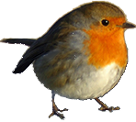



***Saturday, April 7th, from 11:30am-2:00pm, will be the Victorian Villa’s Spring Fling! Each resident may invite 2 family members. Sign-up sheets will be at the front desk, in the main lobby. We will be serving a buffet style luncheon, play bingo and have an artwork display.***

***Please see activity staff members for more details.***

***The Victorian Villa will be hosting a “Bonworth Fashion Show”, on March 28th from 2:00-4:00pm. Family is invited to join your loved one for an afternoon of fun and shopping! All the fashions shown, will be available for purchase. Clothing prices average 19.99 or less.***

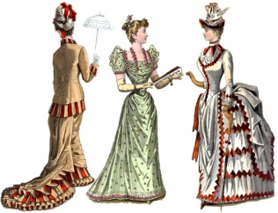

***March Birthdays***

**Celebrate our March Birthdays on Tuesday, March 13th at 2:00pm. Jimmy Edwards will be our entertainer!**

C:\Program Files (x86)\Microsoft Office\MEDIA\CAGCAT10\j0336075.wmf

**________________________________**

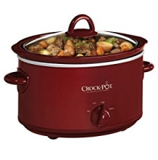

***March 20th is the First Day of Spring! To celebrate, we will be having a Cook-Off Contest! The theme will be Crock-Pot Desserts! On March 20th, we will make our recipe and serve it in the afternoon, to a panel of judges. See the Activity Department for specifics regarding this activity.***

***Voter Awareness Program***

**On Thursday, March 8th at 2:00pm, Tom Smithfield will be here to present a program about the importance of voting. As senior members of our community, our vote continues to be important! Any questions you may have, regarding the voting process, can be answered by Tom. We will have light refreshments following the program.**



*All Around The Villa*

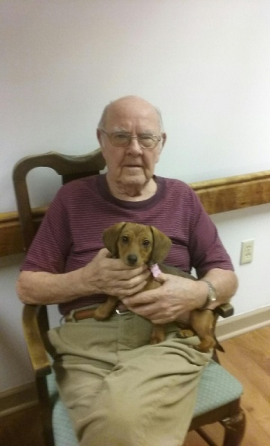

**“Willow and Rodger”**

**Willow is Linda Jermyn’s 4 month old Daschund! She is so adorable and sweet, we just love to cuddle with her! Pet therapy is one of our favorite activities!**

**Callin All Bird-Lovers!**

**We will have a guest speaker from the Audobon Society here, March 22nd at 2:00pm. Pastor Benjamin Leese, will present a powerpoint program that highlights birds, throughout the year, in York County.**

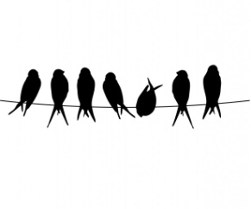

**Please feel free to direct any questions or concerns to the appropriate department:**

**Sue Boone– Administrator**

**Tiffany Kauffman – Personal Care Admin.**

**Linda Jermyn – Social Services**

**Stacie Achenbach – Food Service Director**

**April Snyder – Environmental Services**

**Diana Bixler – Activity Director**

**Woody Harrison- Maintenance**

**Steph Freed-Staff Developement**