The Victorian Times
January 2018

Victorian Villa Personal Care Home
621 E. Main St.
Dallastown, PA 17313
(717) 244-9722
Website:
www.dallastownnursingcenter.com
You can email your loved one anytime at the following email address:
sboone@dallastownnursingcenter.com
“Winter in Pennsylvania”
We can’t imagine winter in Florida or LA,
We can’t imagine not waking up to snow on a winter’s day.
There’d be no snow or icicles or skating on the lake,
Instead we’d be swimming and lying in the sun to bake.
There’d be no sledding down the hill,
Instead we’d be swimming for a thrill.
How could we have a snowball battle without a pile of snow?
We’d have to go to the beach, the beach ball we would throw.
There’d be no need for snowplows or salt to melt the ice.
To have a winter without snow just wouldn’t be nice.
We complain & grumble about the cold, when outside we go,
But we wouldn’t trade it for warm weather
PLEASE BRING ON THE SNOW!!
-from the archives of
The Villa Poets

HAPPY NEW YEAR! It’s hard to believe that another year has gone by and a new one has just begun! We at the Victorian Villa would like to wish everyone blessings, joy and peace in the New Year!

Megan , our visiting artist, will be here on Tuesday, January 16^{t,} at 1:30pm. Join her, in the 3rd Floor Lounge, to create wonderful works of art!
January Birthdays:

1/27 Bruce S.

Celebrate our January birthdays on 1/9 at 2:00pm. Dave Jacoby will be here
to entertain us!
_________________________
Please join us, for a special performance, on Saturday, January 20th at 2:00pm. Orman “Skip” Morton will be here to entertain us! He is a singer, impersonator and performer. He will be presenting “The Wonder of You”, which is a Tribute to Elvis, Tom Jones, The Rat Pack, Roy Orbison and the Oldies.

“Villa Happenings”
December was a very busy month for us!
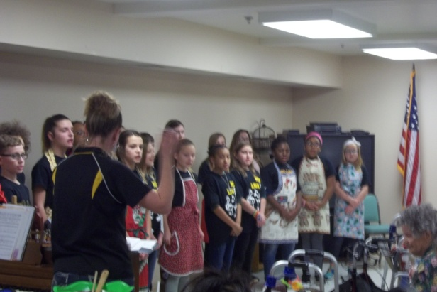
The Red Lion Elementary Choir was in to visit us!
Please feel free to direct any questions or concerns to the appropriate department:

Sue Boone – Administrator
Tiffany Kauffman– Personal Care
Administrator
Linda Jermyn – Social Services
Stacie Achenbach – Food Service
Director
April Snyder – Environmental Services
Diana Bixler – Activity Director
Woody Harrison-Maintenance

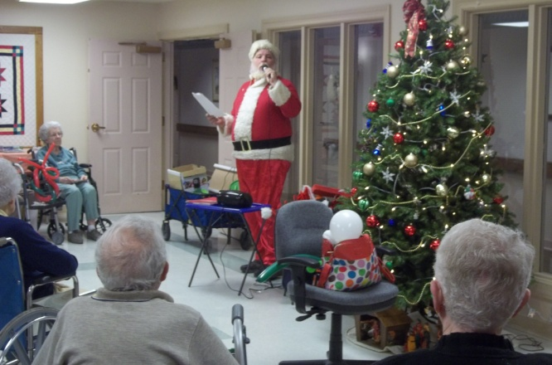
“Characters with Character” also paid us a visit-as Mr. & Mrs. Santa Claus!

Please feel free to direct any questions or concerns to the appropriate department:

Sue Boone – Administrator
Jennifer Warfel – Personal Care
Administrator
Linda Jermyn – Social Services
Stacie Achenbach – Food Service
Director
April Snyder – Environmental Services
Diana Bixler – Activity Director

