IRON WILL: DICUS SHOWED A PASSION FOR BASEBALL
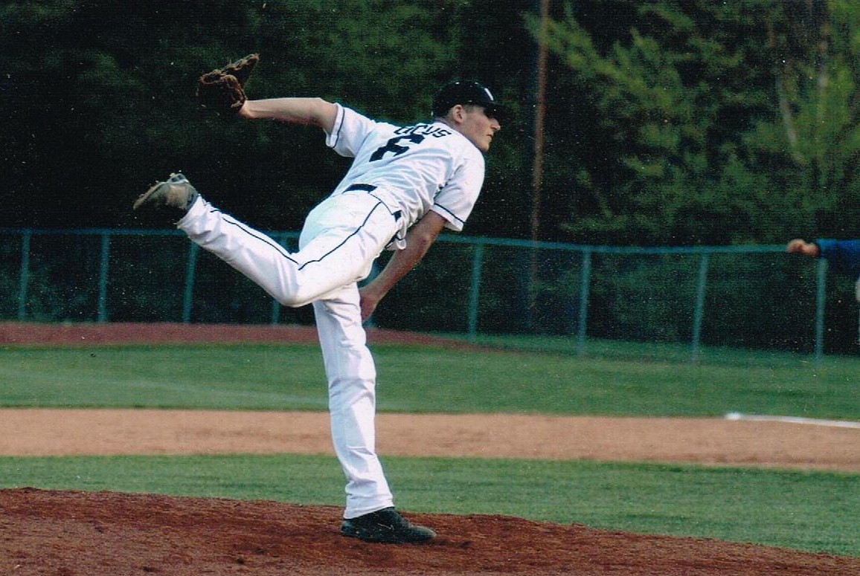
By Steve Behr, Sports Editor Watauga Democrat

You didn’t have to know Will Dicus to be saddened by his passing.

Dicus, the very popular Watauga High student-athlete, passed away Monday night,
losing his battle with cancer.

I knew Dicus mostly through our mutual love for baseball. Well, I love the game. I love watching it on all levels. I’ve spent myself into debt watching the game, driving five hours to Atlanta and seven hours to DC to see teams I could really care less about. I also do everything else humanly possible to make sure that my trips back to Colorado involve stopping by Coors field and watching the Colorado Rockies.

Dicus did more than love baseball. He took it to another level. He had a passion for it. It is that passion that that drove him to fight this horrible disease. It’s that passion for the game
and for life that those who loved him will remember.

It started in Little League when a 12-year old Dicus could throw fastballs as hard as kids two years older than him. In the world of youth baseball, that’s significant. Cancer took away his fastball but it didn’t take away his passion for the game. Dicus became a student of baseball, especially pitching. I can close my eyes and hear him at the Optimist Park fields, asking nobody in particular why a pitcher would throw a curveball in one situation, or why he couldn’t locate his fastball.

His impact on the game, locally, was felt both at Optimist Park and the Northwestern 4A
Conference fields Watauga where played. His no-hitter in 2008 against Freedom’s jayvee team proved that a pitcher can win with his brain and location of his pitches. Throwing 90 miles an hour certainly helps, but good hitters can beat the heat,especially when they know it’s coming and where it’s going to go. It’s a lot tougher to hit a ball not knowing any of that in advance.
Dicus knew this. He was the Pioneers’ version of the player-coach in his senior season. When
Watauga’s opponents would be taking infield, Dicus would be the one urging his teammates to pay attention to what was going on in the field. “Check out the center fielder’s arm. We can run on him,” he might say. It was one of the rare times that Dicus brought attention to himself. When he was first diagnosed, several cars in the High Country had bumper stickers that read “Pray For Dicus.” He appreciated the thought, but also knew he was not alone. There were other kids in the area who were fighting cancer and he felt no more special than them.

He was special to the Watauga baseball program. The team, with South Caldwell’s blessing, moved their Senior Night from the traditional final game of the year to the first NWC game. One by one, the South Caldwell players hugged Will and his mother Pepi, showing things are more important than winning a baseball game.

I remember a few years ago he, his father Bill Dicus and I sat down to have some lunch
and to talk about his recovery. He had been through a long journey of hospitals, chemotherapy and everything else involved. He talked honestly about the disease and dealing with it. After thinking of all the details he gave during that conversation, two stand out. One was his honesty and his candor when we talked. I’ll remember his compassion about others who fought the disease and his determination to beat a formidable opponent.
Secondly, I remember him wanting a Pug dog. None were available in the area so his father and a family friend drove Will to Atlanta to get one. “When your son has cancer and he wants a Pug, you get him one,” Bill Dicus said. No doubt it’s a sad day but I’ll smile when I think of Dicus. I will smile when I think about the time he pitched on the varsity level against West Wilkes last year, collecting a win against a good opponent. I will remember those days at Optimist Park and at Watauga’s field, being able to see Dicus and his Dad chat about baseball and any other subjects that came up at the time. Most of all I’ll remember a guy who had a passion for the game I love, and I’ll smile through the tears.

