C O N C E R T

Classical Guitarist

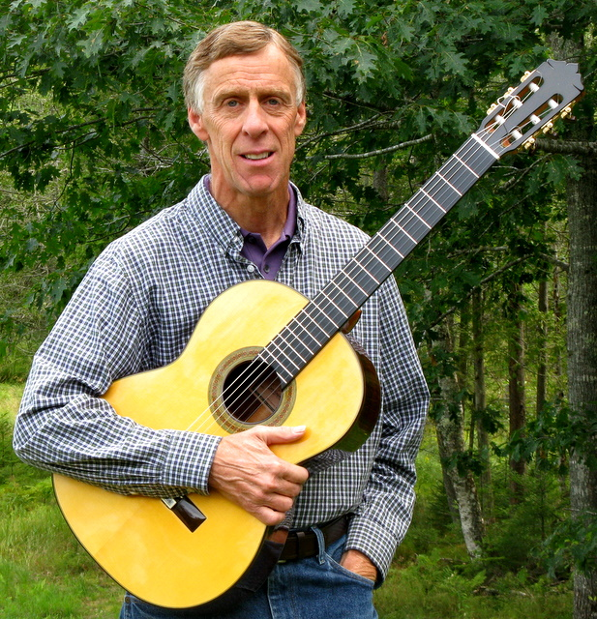 | Kevin Morse  “The Ultimate Classical Guitarist”  Guitar Player Magazine

Friday, S E P T E M B E R 1 6 ^{th} 8.00 PM

Bar Harbor Congregational Church
29 Mount Desert Street, Bar Harbor

Admission: $ 15.00
Presented by:
Guitars of Madrid
95, Whitney Farm Road
Mount Desert, ME 04660
(207) 244-4319
guitarsofmadrid.com

