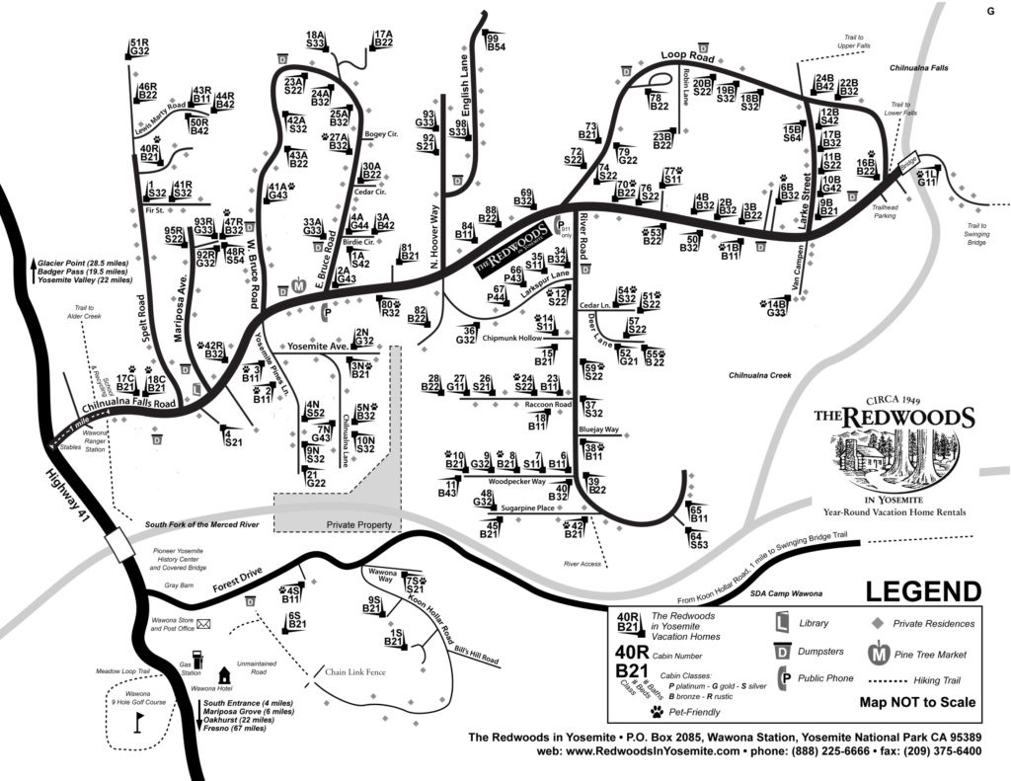

**Coyle’s Cabin 40**

**Redwoods in Yosemite Office**