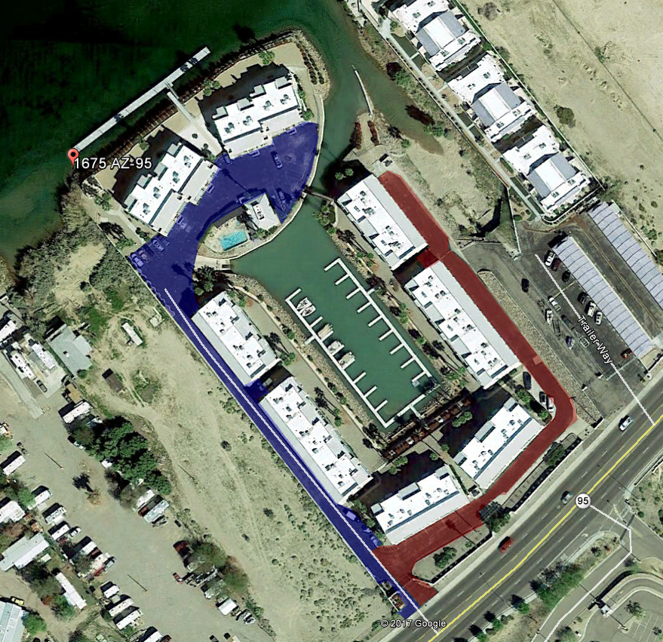
Blue Area 9/24/18 —This area will be closed from 7AM on 9/24/18 and be closed until 2 pm on 9/25/18
Red Area 9/26/18 -- This area will be closed from 7AM on 9/26/18 and be closed until 2 PM on 9/27/18

