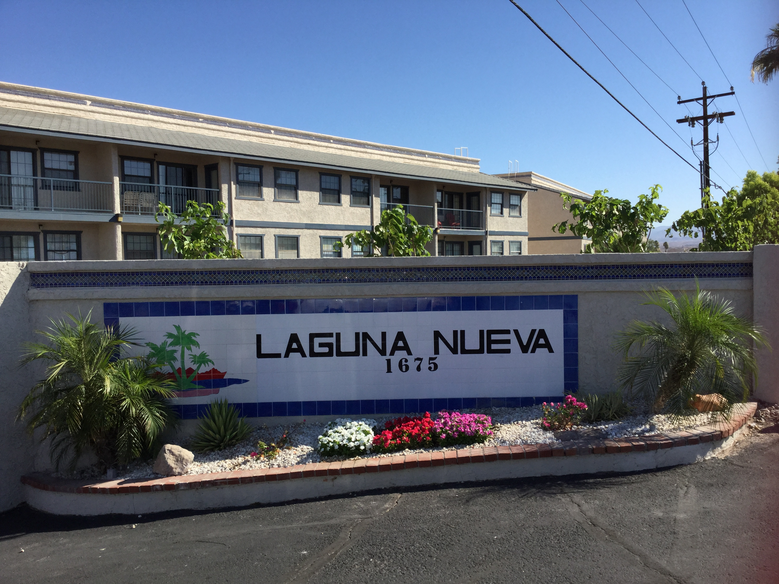

Laguna Nueva Board of Directors
2016

- President, Ric Mc Carthy
- Vice President, Julie Thompson
- Treasurer, Lorraine Foster
- Secretary, Dijon Woods
- Joanne Ward, Member at Large

