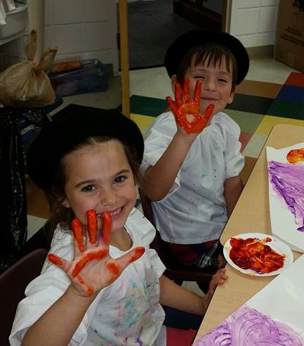

2019

**SUMMER**

**What:**

**Summer Camp** **for children**

**2 through 10 years of age**

Come spend the

Summer with us!

**When:**

**Monday through Thursday**

8:30 a.m. to 1:00 p.m.

**Session (1) June 3 - June 27**

**Session (2) July 1- July 25**

**Where:**

**Gulf Beach Baptist Church**

10620 Hutchison Blvd

PCB, FL 32407

For more information call:

Shea Johnson 850- 234-8892

**Cost:**

**$420**- Session 1 (4 weeks)

**$420**- Session 2 (4 weeks)

**$40 Registration Fee per session**

**CAMP**

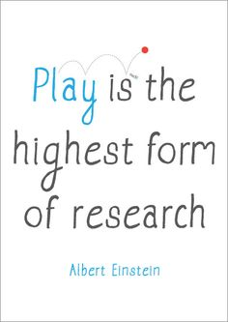

**Our Summer Camp Program provides a unique learning experience that will keep your child engaged and enthusiastic all summer long. Indoor and outdoor activities will provide children with vast opportunities for learning and exploration. Each session includes hands-on themed activities, special art projects, and outdoor water play!**

**To sign up:**

**Call 850-249-5437, email** [**gbbcprek@knology.net**](mailto:gbbcprek@knology.net)

**or register online at**

**www.gbbcprek.com**