Dear friends and supporters of Oak Ridge Baseball,
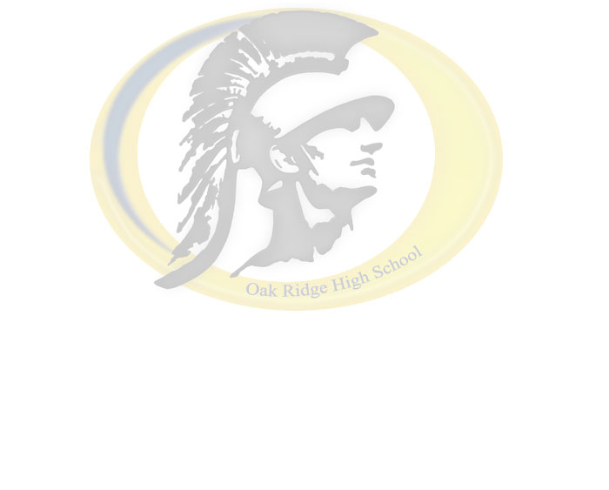
The Oak Ridge Baseball Program consists of three levels operating on a very tight budget. In order to develop and maintain a competitive program, fundraising is extremely important and is necessary to improve our fields, uniforms, and equipment. We are asking for your help to keep our baseball program running at the highest level possible and give our players the best chance to succeed.

We are offering banner advertising for any business or person wishing to purchase a 4’ x 8’ sign that will be attached to our baseball fence. The banner will be in plain view to all spectators for the high school and summer season as well as during our Little League clinics. We are anticipating approximately 600 players to participate in the clinics. We are asking for a $400.00 donation for the first season. When it comes time to renew for the upcoming seasons, a donation of $200.00 per year will be asked. If you would like to participate, please fill out the information on the lower half of this form.

Make checks payable to and mail to:

  Oak Ridge Baseball
C/O Todd Melton – Head Varsity Baseball Coach
1120 Harvard Way
El Dorado Hills, CA 95762-4324

If you know of any business that might be interested in participating, please pass this information along to them. If you have any questions, feel free to call Todd Melton at (916) 425-1821.

Thank-you for your time and support!

 - - - - - - - - - - - - - - - - - - - - - - - - - CUT HERE - - - - - - - - - - - - - - - - - - - - - - - - - -

Name of Business:
Mailing Address:
City: _____________________ State: _______ Zip Code: ________
Telephone #: (___)_____-______ Fax #: (___)_____-______
Email: _____________________ Contact Person: ___________________

Note: Please include a business card with logo and any special instructions for the banner design.

Special Instructions:________________________________________

