**Cosine rule**

**Question 1**

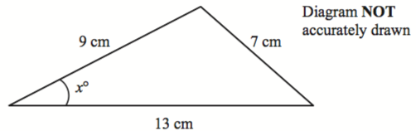

Calculate the value of $x$.  
Give your answer correct to 1 decimal place.

$x=$.......................... $^{°}$

**(3 marks)**

**Question 2**

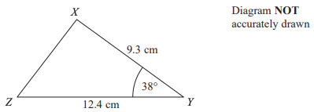

$XYZ$ is a triangle.

$XY=9.3$ cm $YZ=12.4$ cm  
Angle $XYZ={38}^{°}$

Work out the length of $XZ$.  
Give your answer correct to 3 significant figures.

**..........................** cm

**(3 marks)**

**Question 3**

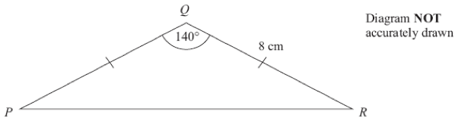

Calculate the length of *PR*.  
Give your answer correct to 3 significant figures.

$PR=$**..........................** cm

**(3 marks)**

**Question 4**

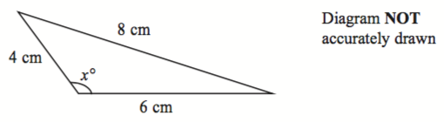

Calculate the value of $x$.  
Give your answer correct to 1 decimal place.

$x=$**.......................... $^{°}$**

**(3 marks)**

**Question 5**

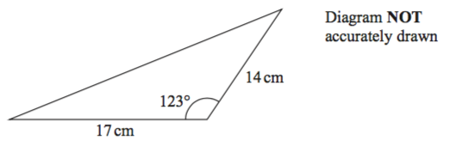

Calculate the perimeter of the triangle.  
Give your answer correct to 1 decimal place.

**..........................** cm

**(4 marks)**

**Question 6**

A circular clock face, centre *O*, has a minute hand *OA* and an hour hand *OB*. *OA* = 10 cm. *OB* = 7 cm.

Calculate the length of *AB* when the hands show 5 o’clock.  
Give your answer correct to 3 significant figures.

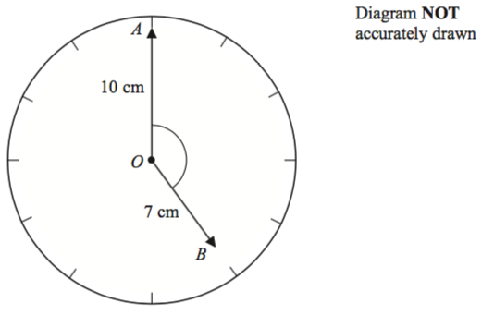

**..........................** cm

**(4 marks)**

**Question 7**

The diagram shows triangle *LMN*.

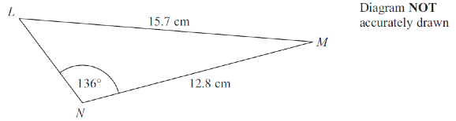

Calculate the length of *LN.*  
Give your answer correct to 3 significant figures.

**..........................** cm

**(5 marks)**

**Answers**

**Question 1**

30.8

../uploads/users/1379/images/img-1379-1551462980-628.png

**Question 2**

any value in the range 7.64 cm to 7.65 cm

../uploads/users/6190/images/img-6190-1582197463-902.png

**Question 3**

$PR=$ 15.0 cm

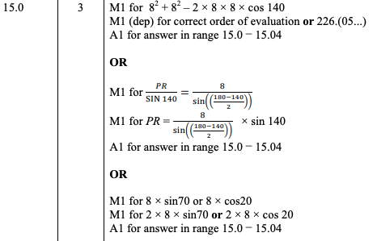

**Question 4**

$x=$ 104.5 $^{°}$

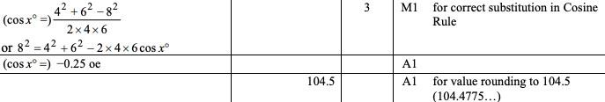

**Question 5**

58.3 cm

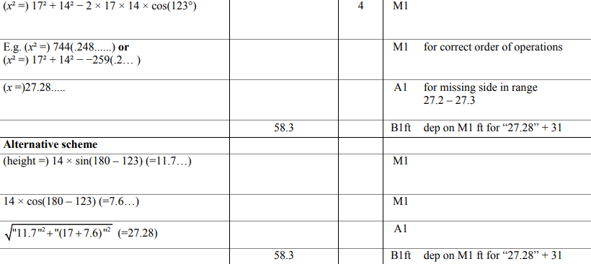

**Question 6**

16.4 cm



**Question 7**

any value in the range 3.73 cm to 3.74 cm

