**Sine rule**

**Question 1**

The diagram shows triangle ABC.

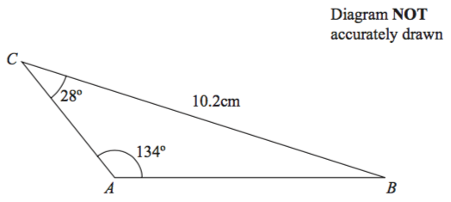

Angle BCA = 28°  
Angle CAB = 134°  
BC = 10.2 cm.

Calculate the length of AB.  
Give your answer correct to 3 significant figures.

.......................... cm

**(3 marks)**

**Question 2**

*P* and *Q* are two points on a coast. *P* is due North of *Q*.  
A ship is at the point *S*. *PS* = 2.9 km.  
The bearing of the ship from *P* is 062°.  
The bearing of the ship from *Q* is 036°.

Calculate the distance *QS*.  
Give your answer correct to 3 significant figures.

**..........................** km

**(3 marks)**

**Question 3**

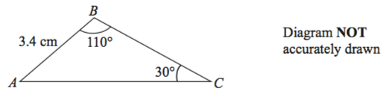

Calculate the length of *AC*.  
Give your answer correct to 3 significant figures.

**..........................** cm

**(3 marks)**

**Question 4**

Here is a quadrilateral $PQRS$.

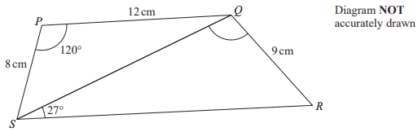

Angle $SRQ$ is acute.

Work out the size of angle $SQR$.  
Give your answer correct to 1 decimal place.

**.......................... $^{°}$**

**(6 marks)**

**Question 5**

**Question 6**

