**9.1 to 9.5 Vectors**

You need to be able to:

* use vectors in two dimensions, including the use of **i** and **j** unit vectors
* calculate the magnitude and direction of a vector;
* add and subtract vectors, multiply by scalars and understand their geometrical interpretations;
* understand and use position vectors, and calculate the distance between two points represented by position vectors;
* use vectors to solve problems.

You have seen vectors and scalars before when you studied GCSE Maths.

* A vector has a direction and a magnitude (or size).
* A scalar is a number.

**Notation**

In print a vector is represented by a bold letter, for example **a**.

When hand-writing, you usually represent a vector by drawing a wavy line underneath the letter, for example a.

If a vector is drawn from *A* to *B*, you use the notation .

You can also represent vectors using arrows.

**a**

–**a**

2**a**

Vectors **a** and –**a** have equal magnitude, but opposite directions.

You can multiply a vector by a scalar. 2**a** has the same direction as **a**, but twice the magnitude.

**Adding and subtracting**

You can add vectors.

*B*

*C*

*A*

**

**

**



This is easiest to understand when the vectors represent translations; if you first translate from *A* to *B* and follow this by a translation from *B* to *C*, the result is a translation from *A* to *C*.

**a**

**b**

**a** + **b**

This diagram is the same, but uses different notation.

When you add vectors **a** and **b** you get vector **a** + **b**.

**b**

**a** + **b**

**a**

You can also represent vector addition using a parallelogram.

The vectors **a**, **b** and **a** + **b** in this diagram are the same as in the previous diagram,

**a**

–**b**

**a** – **b**

Subtracting a vector is the same as adding a negative vector.

**a** – **b** = **a** + (– **b)**

**a**

**b**

*A*

*B*

**

**–a**

*O*

If the position vector of *A* is **a** and the position vector of *B* is **b**,  
 it is useful to remember the following.



**Component form of a vector**

On the following diagrams, one square on the grid represents one unit.

*x*

*O*

*y*

**i**

**j**

The vector **i** is a unit vector in the direction of the *x*-axis and the vector **j** is a unit vector in the direction of the *y*-axis.

A unit vector has a length (or magnitude) of 1 unit.

**i** =  and **j** = 

**Note: | i |** means: the magnitude of **i**. So **| i |** = 1

The point *A* has coordinates (3, 2).

*x*

*O*

*y*

*A*

*B*

*C*

The position vector of point *A* is .

The vector has two components (**i** and **j**).

= 3**i** + 2**j** and the column vector .

The vectors  and  are parallel and equal;   
both are represented by the same column vector .

In the diagram above  and .

And  is equivalent to . You can check this using the diagram.

**Finding the magnitude and direction of a vector**

You can find the magnitude of vectors by using Pythagoras’ theorem.

For example for vector 

You can use the formula .

Vector

Angle

*x*

The direction of a vector is the angle between the positive *x*-axis and the vector, measured in an anti-clockwise direction from the positive *x*-axis.

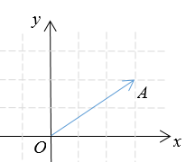

To find the direction you can use the tan ratio for right-angled triangles.

For example for vector , the direction is .

You can use the formula: , but you need to be careful and check in which quadrant *a***i** + *b***j** lies. It is always a good idea to draw a sketch of the vector to make sure that your answer is sensible.

**Magnitude–direction form of a vector**

As well as component form, you can also express a vector in magnitude-direction form.

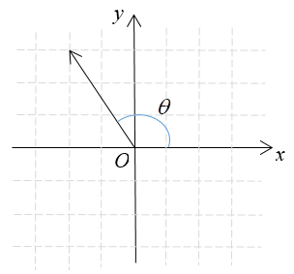

The diagram shows the vector –2**i** + 3**j** and   
  
you can calculate its direction and its magnitude.



To find the direction, *θ*, use the tan ratio.



or



The magnitude-direction form of the vector is .

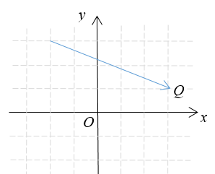

*P*

Examples

**Example 1 (a)** Express vectorin terms of **i** and **j**.  
**(b)** Express vector as a column vector.  
**(c)** Find .

|  |  |
| --- | --- |
| **(a)**  **(b)**  **(c)** | You can see this as 5 steps to the right and 2 steps down.  You can use Pythagoras’ theorem  or |

**Example 2** The position vector of *A* is  and the position vector of *B* is .  
 **(a)** Find .  
 **(b)** Find the direction of vector .  
 **(c)** Express vector in magnitude–direction form.

|  |  |
| --- | --- |
| *A* = (–3, –1) and *B* = (2, 3)    *A*  *B*  *θ*  **(a)**  **(b)**  **(c)** (6.40, 38.7°) | It is often helpful to draw or sketch a diagram when answering vector questions.  You can use Pythagoras’ theorem on the triangle to find  You could also give your answer as (, 38.7°) |

**Note:** Instead of drawing a diagram, you can use the formula



to find the distance *d* between .

**Example 3** The position vectors of *A*, *B* and *C* are  respectively.  
*ABCD* is a parallelogram. Find the position vector of *D*.

|  |  |
| --- | --- |
| In parallelogram *ABCD* the sides *BA* and *CD* are equal and parallel, so . | You may find it helpful to sketch the parallelogram *ABCD*.  Substitute  to find , which is the position vector of *D*. |

**Example 4**  and . Point *R* divides *PQ* in the ratio 2 : 3

Find the position vector of *R*.

|  |  |
| --- | --- |
|  | *O*  *P*  *Q*  *R*  The ratio *PR* : *RQ* = 2 : 3,  So |

Exercise

**1.** Point *A* has position vector 4**i** and point *B* has position vector 2**i** – 3**j**

**(a)** Express vector  in terms of **i** and **j**.

**(b)** Find . Give your answer as a simplified surd.

**2.** Write the following vectors in magnitude-direction form.

**(a)** 6**i *+*** 8**j** **(b)** –4**i +** 3**j** **(c)** 5**i** – **j (d)** –3**i** – 5**j**

**3.** *OABC* is a square. *O* is the origin and the position vectors of *A* and *C* are 3**i** + 7**j** and 7**i**– 3**j** respectively. Find the position vector of *B* in terms of **i**and **j**.

**4.** Vector **a** = 2**p** + 4**q** and vector **b** = 3**q** – 2**p**. Express the following vectors in terms of **p** and **q**.

**(a)** 3**a** **(b) a** + **b** **(c)** 5**a** – **b** **(d)** –7**b**

**5.**  and . Point *R* divides *PQ* in the ratio 1 : 4

Find the position vector of *R*.

**6.** The diagram shows a sketch of triangle *OAB.*

*A*

*O*

*B*



**(a)** Find 

**(b)** Calculate angle *AOB* to one decimal place.

**7.** Point *A* has position vector 4**i** and point *B* has position vector 2**i** – 3**j**. Point *C* lies on the *y*-axis. It is given that  Find the position vector of *C* in terms of **i** and **j**.

**8.** Find the values of *m* and *n* when 

**9.** *O* is the origin and in the rhombus *OABC* vectors .

**(a)** Express vector  in terms of **a** and **b**.

**(b)** Express vector  in terms of **a** and **b**.

**(c)** Prove that the two diagonals of the rhombus bisect each other.

Answers

**1. (a)** 

**(b)** 

**2. (a)** 

**(b)** 

**(c)** 

**(d)** 

**3.** 

**4. (a)** 3**a** = 3(2**p** + 4**q**) = 6**p** + 12**q**

**(b)** **a** + **b** = 2**p** + 4**q** + 3**q** – 2**p** = 7**q**

**(c)** 5**a** – **b** = 5(2**p** + 4**q) – (**3**q** – 2**p**) = 10**p** + 20**q** – 3**q** + 2**p** = 12**p** + 17**q**

**(d)** –7**b** = –7**(**3**q** – 2**p**) = –21**q** +14**p** or 14**p** – 21**q**

**5.** 



**6. (a)** 

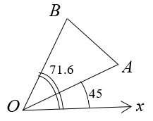 **(b)** Direction   
 and direction 

Angle *AOB* = 71.6° – 45° = 26.6°

**Alternative method** using cosine rule



and 



**7.** ; *A* = (4, 0); *B* = (2, –3); *C* = (0, *c*).



and 

As 

So 

**Alternative method** using geometry

Midpoint of *AB* is (3, –1.5)

Gradient of line *AB* is , gradient of line perpendicular to *AB* is 

Equation of perpendicular bisector is 

When *x* = 0,  

**8.** 

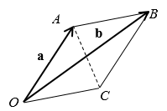 

**9. (a)** 

**(b)** 

**(c)** *M* is the midpoint of *OB*; 

*N* is the midpoint of *AC*; 

So 

The midpoints of the diagonals are the same, therefore the diagonals must bisect each other.